

Piri Reis University

Faculty of Economics and Administrative Sciences

**Management Information Systems Department**

**GRADUATION THESIS – YBS421**

**BUSINESS PROCESS MANAGEMENT(BPM) AND WORKFLOW MANAGEMENT(WFM) TOOLS AND A CASE APPLİCATION**

**DUYGU ÖZGÜN**

**201635012**

Advisor: Assoc. Prof. Batuhan KOCAOĞLU

İstanbul June, 2021

DECLARATION

I hereby declare that this thesis represents my own work which has been done after registration for the degree of bachelor at Piri Reis University, and has not been previously included in a thesis or dissertation submitted to this or any other institution for a degree, diploma or other qualifications.

Signature:

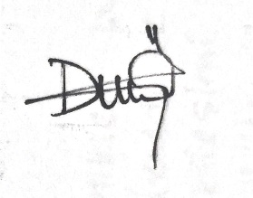

Date: 27/05/2021

ACKNOWLEDGEMENT

I am really grateful Associate Professor Batuhan Kocaoğlu, who contributed to this work and helped me at every stage of my thesis, Cem Onur Pala Bey, who supported me with all the details of the project I will develop in the system, supported me with his ideas and knowledge, and my classmates, whose ideas I received during the difficult stages of my research, my family who have shown me patience in my studies and to everyone who has given me a little or great help during my work.

ABSTRACT

Workflow management is used effectively in matters such as transfer transactions, document and paperwork transactions, which are the areas where business life needs the most. The use of Workflow systems by companies are steps that produce meaningful results for them to produce more efficient work. BPM, on the other hand, aims to reveal the business processes of the enterprises, to document them, to make improvements and to make the steps automatically.

In this study, business process management and workflow management are covered in detail. A topic directly proportional to workflow management and business process management has been selected (new product commissioning) and the work flow has been created on this subject and then the application has been developed from the Synergy platform so that the it has been allowed to be formed into forms.)

**Key Words:** Workflow Managemet, Business Process Management, Synergy Platform, Automating documents,

İçindekiler

DECLARATION 2

ACKNOWLEDGEMENT 3

ABSTRACT 4

1 INTRODUCTIOn 6

1.1 WORKFLOW MANAGEMENT SYSTEMS 6

1.1.1 International standards 6

1.1.2 Workflows for people 6

1.1.3 Automated workflows 7

1.1.4 List of notable WfMS 7

1.1.5 The15 Best Workflow Management Software 8

1.1.6 Workflow Management Software Selection Criteria 8

1.2 BUSINESS PROCESS MANAGEMENT(BPM 9

1.2.1 What BPM is Not 9

1.2.2 What are the Various Types of Business Process Management Systems? 10

1.3 BPM Lifecycle: The 5 Steps in Business Process Management 10

1.3.1 Step 1: Design 10

1.3.2 Step 2: Model 10

1.3.3 Step 3: Execute 10

1.3.4 Step 4: Monitor 11

1.3.5 Step 5: Optimize 11

1.4 What are the Benefits of Implementing Business Process Management? 11

1.5 When should Organizations Implement Business Process Management? 11

1.6 The goal of the project 12

1.7 Good / similar examples 12

2 REQUIRED TOOLS 13

2.1 The platforms used to write the project 13

2.1.1 What is Bimser Synergy Platform? 13

2.2 Required Software Download Links 14

3 SOLUTION APPROACH 16

3.1 Flowchart of Project 16

3.2 Project Steps With Gannt Chart 17

4 SYSTEM DEVELOPMEnt process 18

4.1 Installation of the required tools 18

4.2 Development environments and processes 18

5 BUSINESS CASE 23

5.1 Explaination implementation project 23

6 CONCLUSION 36

6.1 Advantages of Project 36

6.2 Advantages and drawbacks in the projects 37

6.3 Difficulties encountered in the project and their solutions 37

6.4 Possible improvements for further studies. 37

6.5 Similar project explanation 38

6.6 Project contributions 38

7 REFERENCES 39

CURRICULUM VITAE 41

lıst of fıgures

1.BPM Lifecycle 12

2.permission request process form (sample demonstration) 14

3.Examples of workflow 15

4.Main Page of Bimser Platform1 17

5.Main page of Bimser Platform 17

6.Project Flowchart 18

7.Project Gantt Chart 19

8.Start page of Bimser Synergy 20

9.Excel draft1 20

10.Excel draft2 21

11.Excel draft3 21

12.Excel draft4 21

13.Create flowchart page 22

14.Flowchart of business process 23

15.Test-case diagram 37

# INTRODUCTIOn

Today's business world, full of multidimensional and interconnected systematic challenges, is defined by a comprehensive division of labor. As a result of many researches, it is seen that the biggest enemy of the sustainable efficiency and success of the rapidly changing business world is the increasingly complex business models. Products and services can be provided by a regulated and repeatable business model that is provided by systematically transforming resources into processes. In the continuation of production and services without losing the productivity increase in global competition conditions; Defining the coordination between internal and external actors in the organization well, keeping it up-to-date according to changing conditions, effective control and improvement at regular intervals or according to needs are vital for businesses. The first step towards a smooth process is to ensure the transparency of the business process that results in product and service delivery. This transparency can be achieved by documenting the business process, including the various relevant actors, the activities they perform, the events and decisions that affect the progress, and the information produced and consumed. Labor division in business processes requires coordination support with the help of information systems. Information systems that explicitly support business processes are often referred to as process awareness information systems. Office automation systems, workflow management systems and, more recently, business process management systems support process execution based on determining the process as a formal business process model. Business Process Management (BPM) is about all management activities around business processes. In the past, activities related to business process management were carried out by process analysts, process managers and process engineers in a labor-intensive manner, with almost no automatic support, except for the creation of system configuration from the executable process model. Later, various techniques have been developed to provide smart support to process stakeholders at various stages of business process management Business Process Management is the discipline that brings together information in information technology and management sciences and adapts them to operational business processes. This discipline has attracted great attention in recent years for its potential to significantly increase productivity and reduce costs. These systems are general software systems driven by open process designs to implement and manage operational business processes. On the other hand, BPM is often associated with software to manage, control and support operational processes.

## WORKFLOW MANAGEMENT SYSTEMS

A **workflow management system** (**WfMS** or **WFMS**) provides an infrastructure for the set-up, performance and monitoring of a defined sequence of tasks, arranged as a [workflow application](https://en.wikipedia.org/wiki/Workflow_application).

### International standards

There are several international standards-setting bodies in the field of workflow management:

* [Workflow Management Coalition](https://en.wikipedia.org/wiki/Workflow_Management_Coalition)
* World Wide Web Consortium
* Organization for the Advancement of Structured Information Standards
* WS-BPEL 2.0 (integration-centric) and WS-BPEL4People (human task-centric) published by OASIS Standards Body.

The underlying theoretical basis of workflow management is the mathematical concept of a [Petri net](https://en.wikipedia.org/wiki/Petri_net).

Each of the workflow models has tasks (nodes) and dependencies between the nodes. Tasks are activated when the dependency conditions are fulfilled.

### Workflows for people

WfMS allow the user to define different workflows for different types of jobs or processes. For example, in a manufacturing setting, a design document might be automatically routed from designer to a technical director to the production engineer. At each stage in the workflow, one individual or group is responsible for a specific task. Once the task is complete, WfMS ensures that the individuals responsible for the next task are notified and receive the data they need to execute their stage of the process.

Workflows can also have more complex dependencies; for example if a document is to be translated into several languages, a translation manager could select the languages and each selection would then be activated as a work order form for a different translator. Only when all the translators have completed their respective tasks would the next task in the process be activated. It is process management from top level to lower level.

WfMS also automate redundant tasks and ensure that uncompleted tasks are followed up. A key standard that deals with human tasks in workflows is the WS-BPEL4People Standard by the OASIS Standards Body.

### Automated workflows

WfMS may control automated processes in addition to replacing paper work order transfers.

For example, if the above design documents are now available as AutoCAD but the workflow requires them as Catia, then an automated process would implement the conversion prior to notifying the individual responsible for the next task. This is the concept of [enterprise application integration](https://en.wikipedia.org/wiki/Enterprise_application_integration).

WfMS also appear in distributed IT environments such as [grid computing](https://en.wikipedia.org/wiki/Grid_computing) or [cloud computing](https://en.wikipedia.org/wiki/Cloud_computing). The aim of such systems is to manage the execution of various processes that may belong to the same application while in many cases they are used as a means to guarantee the offered [quality of service](https://en.wikipedia.org/wiki/Quality_of_service) (QoS).

WfMS may also be enhanced by using existing enterprise infrastructure such as Microsoft Outlook or Office 365.

### List of notable WfMS

* [Activiti](https://en.wikipedia.org/wiki/Activiti_(software))
* [Apache ODE](https://en.wikipedia.org/wiki/Apache_ODE)
* [Apache Taverna](https://en.wikipedia.org/wiki/Apache_Taverna)
* [Apache Airflow](https://en.wikipedia.org/wiki/Apache_Airflow)
* [Appian](https://en.wikipedia.org/wiki/Appian_Corporation)
* [Bizagi](https://en.wikipedia.org/wiki/Bizagi)
* [Bonita BPM](https://en.wikipedia.org/wiki/Bonita_BPM)
* [Camunda](https://en.wikipedia.org/wiki/Camunda)
* [CEITON](https://en.wikipedia.org/wiki/CEITON)
* [Collective Knowledge](https://en.wikipedia.org/wiki/Collective_Knowledge_(software))
* [Cuneiform (programming language)](https://en.wikipedia.org/wiki/Cuneiform_(programming_language))
* [IBM BPM](https://en.wikipedia.org/wiki/IBM_WebSphere_Process_Server)
* [Imixs-Workflow](https://en.wikipedia.org/wiki/Imixs-Workflow)
* [Intuit QuickBase](https://en.wikipedia.org/wiki/Intuit#QuickBase)[[6]](https://en.wikipedia.org/wiki/Workflow_management_system#cite_note-6)
* [jBPM](https://en.wikipedia.org/wiki/JBPM)
* [Jira (software)](https://en.wikipedia.org/wiki/Jira_(software))
* [PRPC](https://en.wikipedia.org/wiki/Pegasystems)
* [ProActive](https://en.wikipedia.org/wiki/ProActive)
* [Pyrus](https://en.wikipedia.org/wiki/Pyrus_(software))
* [RedBooth](https://en.wikipedia.org/wiki/Redbooth) Workflow Management
* [Salesforce.com](https://en.wikipedia.org/wiki/Salesforce.com) Process Workflow
* [ServiceNow](https://en.wikipedia.org/wiki/ServiceNow) Platform
* [SAP](https://en.wikipedia.org/wiki/SAP_ERP) Business Workflow
* [TACTIC (web framework)](https://en.wikipedia.org/wiki/TACTIC_(web_framework))
* [Windows Workflow Foundation](https://en.wikipedia.org/wiki/Windows_Workflow_Foundation)
* [WorkflowGen](https://en.wikipedia.org/wiki/WorkflowGen)
* [Workfront](https://en.wikipedia.org/wiki/Workfront)
* [YAWL](https://en.wikipedia.org/wiki/YAWL) (wikipedia.org, 2021)

### The15 Best Workflow Management Software

1. [monday.com](https://monday.com/lp/mb/workflow/comparison?utm_source=mb&utm_campaign=dpm&utm_medium=workflow) - Best workflow management software for process visualization
2. [Kissflow](https://kissflow.com/workflow/automate-workflow/?utm_source=thedigitalprojectmanager&utm_medium=ppc&utm_campaign=TheDPM-Workflow&utm_kf_source=TheDPM-Workflow) - Best enterprise workflow management software
3. [Wrike](https://try.wrike.com/workflow-management-software/?utm_source=dpm&utm_medium=cpc&utm_campaign=workflow-management-software) - Best workflow management software for scaling organizations
4. [Admation](https://www.admation.com/?r=wfms) - Best agency workflow management software
5. [Orchestly](https://www.orchestly.com/?utm_source=Digitalprojectmanager&utm_medium=cpc&utm_campaign=workflowmanagement) - Best workflow management software for optimizing processes
6. [Quixy](https://quixy.com/platform) - Best no-code workflow management software
7. [TeamGantt](https://teamgantt.com/?fpr=digitalprojectmanager) - Best For Creating Drag And Drop Gantt Charts
8. [Process Street](https://processstreet.grsm.io/dpm) - Best For Automating Scheduled Tasks
9. [Formstack](https://www.formstack.com/r/48814454) - Best For Small Teams
10. [ProWorkflow](https://lddy.no/6jvq) - Best For Visual Deadline Tracking
11. [Gain](https://gain.grsm.io/dpm) - Best For Social Media Workflows And Approvals
12. [Screendragon](https://hubs.ly/H0y0DbH0) - Best workflow management software for large global teams
13. [Clarizen](https://www.clarizen.com/?r=wfms)
14. [Celoxis](https://www.celoxis.com/?utm_source=thedigitalprojectmanager&utm_medium=ad&utm_campaign=wm-software) - Best reporting and analytics features
15. [ClickUp](https://clickup.com/lp/pm-get-started?utm_source=DPM&utm_medium=Listicle&utm_campaign=workflow-management) - Best free plan for workflow management software

#### Other Workflow Management Software Worth Considering

1. [Asana](https://asana.com/?r=wfms)
2. [MetaTask](https://metatask.io/?r=wfms)
3. [Avaza](https://thedigitalprojectmanager.com/go/workflow-management-software-avaza/)
4. [Pipefy](https://www.pipefy.com/?r=wfms)
5. [inMotionNow](https://www.inmotionnow.com/?r=wfms)
6. [WorkflowGen](https://www.workflowgen.com/?r=wfms)

### Workflow Management Software Selection Criteria

Some workflow automation software is more comprehensive than others—some are focused on managing the workflow itself (assigning tasks, creating dependencies, tracking deadlines). This type of application might also go by the name of workflow diagram software or [flowchart software](https://thedigitalprojectmanager.com/flowchart-software/).

Others offer a more robust workflow management system as part of a broader [resource management software](https://thedigitalprojectmanager.com/resource-management-software/) or [project management software](https://thedigitalprojectmanager.com/best-project-management-software-tools/). As such, they offer a suite of additional business features for creating process forms, handling invoices and payments, modeling data, managing a project portfolio, and more.

In our selection of workflow management software, we narrowed down our criteria to a few key points. These are the essential functions of a useful workflow tool:

#### ****Automation****

This is the whole point of using workflow software. We examine the tools’ time-saving automation functionalities, such as automatically assigning tasks, sending push notifications, routing documentation, reducing repetitive processes, sending status updates, and generating reports.

The best software should include automation tools and full customization for automations, including custom workflows, automated notifications, business rules, process automation, and more.

#### ****KPI reports****

This is usually some type of dashboard with graphic displays of your workflow stats. KPI and metrics reporting not only gives team members insight into their task or [project status,](https://thedigitalprojectmanager.com/project-status-report-guide/) but also gives management insight into where inefficiencies are occurring so you can optimize your business processes.

#### ****Deadline tracking****

Even with a dashboard, when you’re running dozens of workflows, it’s easy to lose sight of deadlines. To be useful, a workflow tool has to offer a clear system for SLA indicators. Tools use notifications, color-coding, and dashboard views that display tasks by due date in order to help you manage deadlines.

#### ****Integrations****

Nowadays, all projects require multiple tools. Your workflow management software absolutely must integrate with other apps that you use for your business. This includes calendars, CMS, development tools, databases, email and [communication tools](https://thedigitalprojectmanager.com/best-communication-tools/), payment processing apps, and more.

#### ****Price****

The value that you get from a workflow tool has to align with the price you’re paying. The best workflow software for you won’t require you to pay for features you don’t need or users you don’t have. We evaluate a tool’s pricing based on its simplicity, transparency, and value offered at the price. (Aston)

## BUSINESS PROCESS MANAGEMENT(BPM

Business process management (BPM), as defined by Gartner, is a discipline that uses various tools and methods to design, model, execute, monitor, and optimize business processes. A business process coordinates the behavior of people, systems, information, and things to produce business outcomes in support of a business strategy.

BPM focuses on putting a consistent, automated process in place for routine transactions and human interactions. It helps to reduce the business’s operational costs by decreasing waste and rework, and by increasing the overall efficiency of the team.

Organizations engaged in BPM can choose to follow one of the various BPM methodologies, which include Six Sigma and Lean.

### What BPM is Not

**BPM is not a software product.** There are BPM tools available that help in implementing standard and automated business processes. For example, [HappyFox Workflows](https://www.happyfox.com/workflows/) helps businesses automate complex, multi-step, and repetitive business processes. BPM, however, is not a software product in itself.

**BPM is not Task Management.** Task or Project Management is about handling or organizing a set of activities. A project management software like Microsoft Project, Jira, Asana, or Trello helps in managing tasks and ad-hoc projects. Business Process Management, on the other hand, is focused more on repetitive and ongoing processes that follow a predictable pattern or process management.

### What are the Various Types of Business Process Management Systems?

BPM systems can be categorized based on the purpose that they serve. Here are the three types of business process management:

#### System-Centric BPM (or Integration-Centric BPM)

This type of business process management system handles processes that primarily depend on existing business systems (e.g., HRMS, CRM, ERP) without much human involvement. A system-centric business process management software has extensive integrations and API access to be able to create fast and efficient business processes. An example of an integration-centric process is online banking, which can include different software systems coming together.

#### Human-Centric BPM

Human-centric BPM considers the people first, supported by various automation functions. These are processes that are primarily executed by humans, and automation does not easily replace them. These often have a lot of approvals and tasks performed by individuals. Examples of human-centric processes include providing customer service, handling complaints, on-boarding employees, conducting e-commerce activities, and filing expense reports.

## BPM Lifecycle: The 5 Steps in Business Process Management

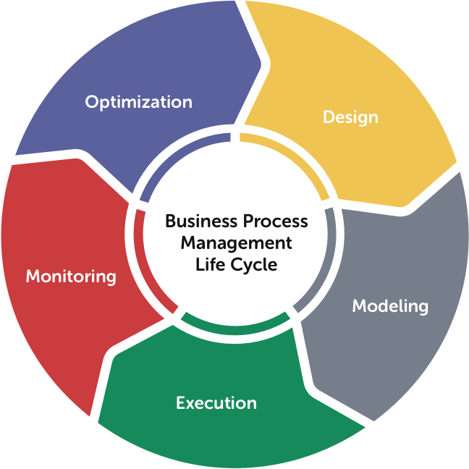

1.BPM Lifecycle

### Step 1: Design

Business analysts review current business rules, interview the various stakeholders, and discuss desired outcomes with management. The goal of the process design stage is to gain an understanding of the business rules and ensure if the results are in alignment with the organizational goals.

### Step 2: Model

Modeling refers to identifying, defining, and making a representation of new processes to support the current business rules for various stakeholders.

### Step 3: Execute

Execute the business process by testing it live with a small group of users first and then open it up to all users. In the case of automated workflows, artificially throttle the process to minimize errors.

### Step 4: Monitor

Establish Key Performance Indicators (KPIs) and track metrics against them using reports or dashboards. It’s essential to focus on the macro or micro indicators – an entire process vs. process segments.

### Step 5: Optimize

With an effective reporting system in place, an organization can effectively steer operations toward optimization or process improvement. Business Process Optimization (BPO) is the redesign of the business processes to streamline and improve process efficiency and strengthen the alignment of individual business processes with a comprehensive strategy.

## What are the Benefits of Implementing Business Process Management?

Business Process Management helps organizations move toward total digital transformation and help them realize bigger organizational goals. Here are some of the key benefits of using BPM in your business:

**1. Improved Business Agility:** Changing and optimizing an organization’s business processes is necessary to keep up with the market conditions. BPM allows organizations to pause business processes, implement changes, and re-execute them. Altering workflows, as well as reusing and customizing them, enables business processes to become more responsive and gives the organization deeper insights into the effects that process modifications have.

**2. Reduced Costs and Higher Revenues:** A business process management tool eradicates bottlenecks, which significantly reduces costs over time. An effect of this can be a reduction in lead times for product sales, giving customers quick access to services and products, which leads to higher sales and improved revenue. BPM solutions can also allocate and track resources to reduce waste, which can also reduce costs and lead to higher profits.

**3. Higher Efficiency:** The integration of business processes brings the potential for end-to-end improvement in process efficiency. With the right information, process owners can closely monitor delays and allocate additional resources if needed. Automation and the removal of repetitive tasks, add to more efficiencies in the business process.

**4. Better Visibility:** BPM software enables automation while ensuring real-time monitoring of key performance metrics. This enhanced transparency leads to better management and the ability to modify structures and processes efficiently while tracking outcomes.

**5. Compliance, Safety, and Security:** A comprehensive BPM guarantees that organizations comply with standards and stay up to date with the law. BPM can also promote safety and security measures by properly documenting procedures and facilitating compliance. As a result, organizations can encourage their staff to safeguard organization assets, such as private information and physical resources from misuse, loss, or theft.

## When should Organizations Implement Business Process Management?

Here are some examples of business processes where implementing BPM will result in a high return on investment.

1. Dynamic processes that require regulatory compliance changes, such as a change in customer information management following changes in finance or privacy laws.

2. Complex business processes that require orchestration and coordination across multiple business units, divisions, functional departments, or workgroups.

3. Measurable mission-critical processes that directly improve a crucial performance metric.

4. Business processes that require one or more legacy applications for their completion.

5. Business processes with exceptions that are handled manually and/or require quick turnarounds. (happyfox)

## The goal of the project

To handle the new product commissioning process with all its stages and to ensure that it passes various approvals and to achieve a whole by creating workflows of these processes. To show clearly the business processes and work flow in the commissioning of new products in the production sector

## Good / similar examples

Many examples of business processes and workflows come to light after research. The issue of new product deployment is a process that needs to be approved by many departments within the company. Such examples include permission request processes, recruitment processes, and are designed to submit to the approval of departments within the company. There are many forms.

A permit request process form and flow section created in Synergy: 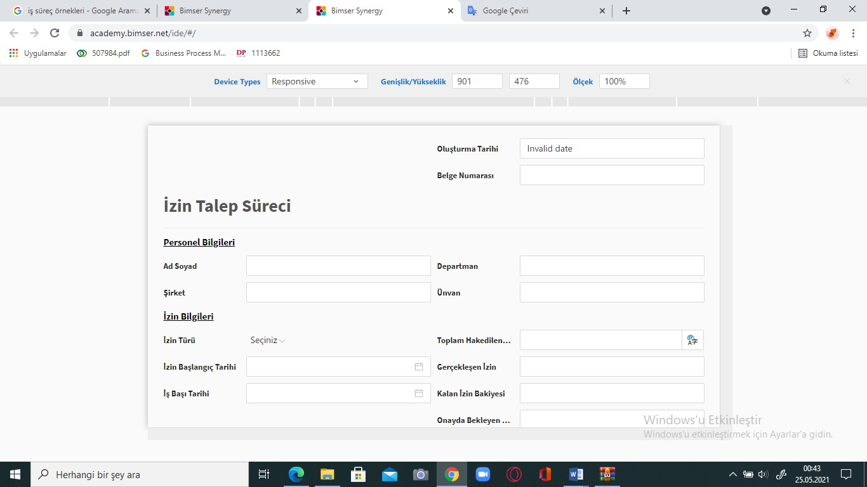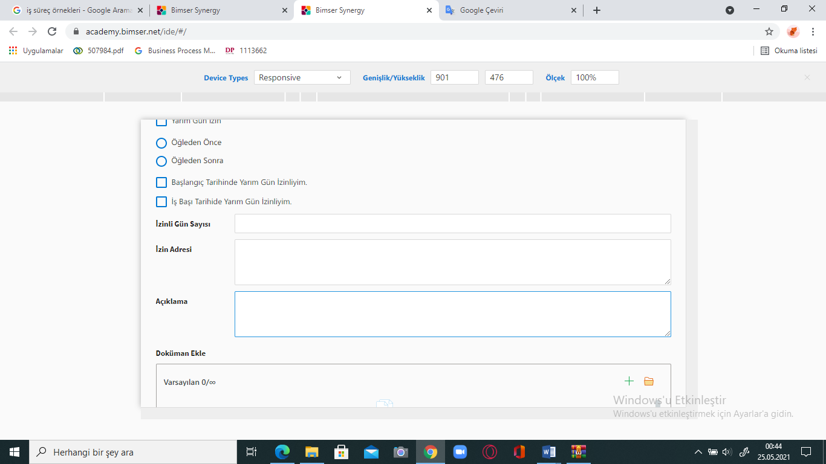

2.permission request process form (sample demonstration)

As can be seen in the figure, a permit request process has been handled and in line with this process, a permit request form was created in Bimser Synergy to accelerate and automate the process.

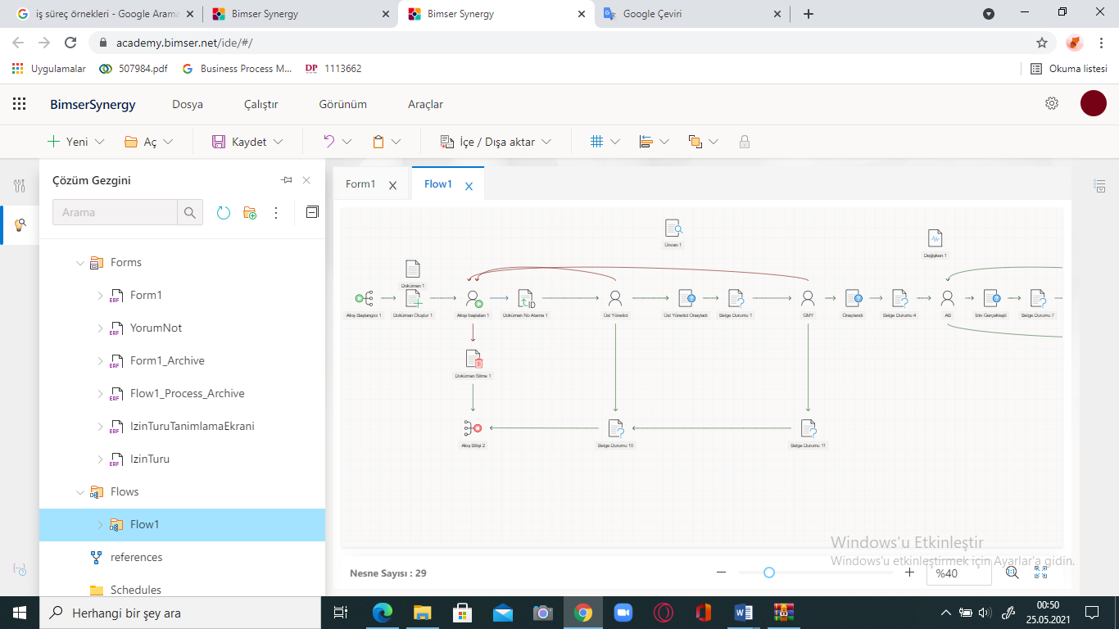

3.Examples of workflow

Later, as we can see in the figure, a work flow part of the form we have created was designed, so that it was specified who was approved and who took which steps in this permit process.

# REQUIRED TOOLS

## The platforms used to write the project

The platform required to create the project is Bimser Synergy Platform. You need a username and password to log into the platform.Bimser Synergy CSP (Content Services Platform) is an integrated and cloud-based content services platform that supports digital transformation, covering document management, workflow management, document management and back-office processes. With Bimser Synergy CSP, designed for all devices and operating systems, workflows are easily drawn, forms are defined and processes are managed effectively and efficiently. Moreover, there is no need to use code.

### What is Bimser Synergy Platform?

Bimser Synergy CSP enables you to manage your today with the infrastructure of the future. It offers powerful, safe and flexible solution models in continuous development. It allows you to capture the fast conversion in digital.

Powerful Interface

Stunning UX

Low Code Platform

Quick Setup

Cooperation and Collaboration

Lifecycle Management of Document

The Search Engine That Recognizes You

#### Company

Founded in Kocaeli in 1998, BİMSER started its journey with people who came together to produce software solutions in the field of information technologies.

For many years, BİMSER has been offering its users a wide range of products that can work in integration with each other and with other products, from software packages for companies of different scales and sectors to a complete solution development platform on which various business applications can be designed. Today, BİMSER's software products are used in more than 1800 distinguished companies in Turkey by more than a million professionals; brings competitive advantage and success to these companies with the efficiency it provides.

BİMSER has exported its software to more than 33 countries so far. The New York and Rotterdam offices that the company launched in 2017 are also a continuation of this development.

Developed entirely by Turkish Engineers, Bimser Synergy plays an important role in digitalization of companies in Turkey and increasing their competitive power with eBA, QDMS, BEAM, ENSEMBLE and eBA: ITSM software products. It continues to be the first choice of leading companies in the sector, especially with its solutions in the fields of document and work flow management, process and performance management, quality management, information security management, risk management, maintenance management and asset and information technology management.

#### Mission

To provide its customers with a competitive advantage through flexibility, efficiency and time saving with the advanced technology software it produces.

#### Vision

To be one of the leading software companies developing business process automation applications in Turkey and to obtain 50% of its turnover from foreign sales in a five-year perspective.

#### Values

To perceive customer needs completely in relations with our customers and to try to produce complete and appropriate solutions.

Trying to provide complete customer satisfaction in all projects.

Fulfilling the promises made on time

To create working methods in line with customer need

## Required Software Download Links

To create a project in Bimser Synergy, the project starts by going to the **academy.bimser.net** extension and logging in with a username and password.

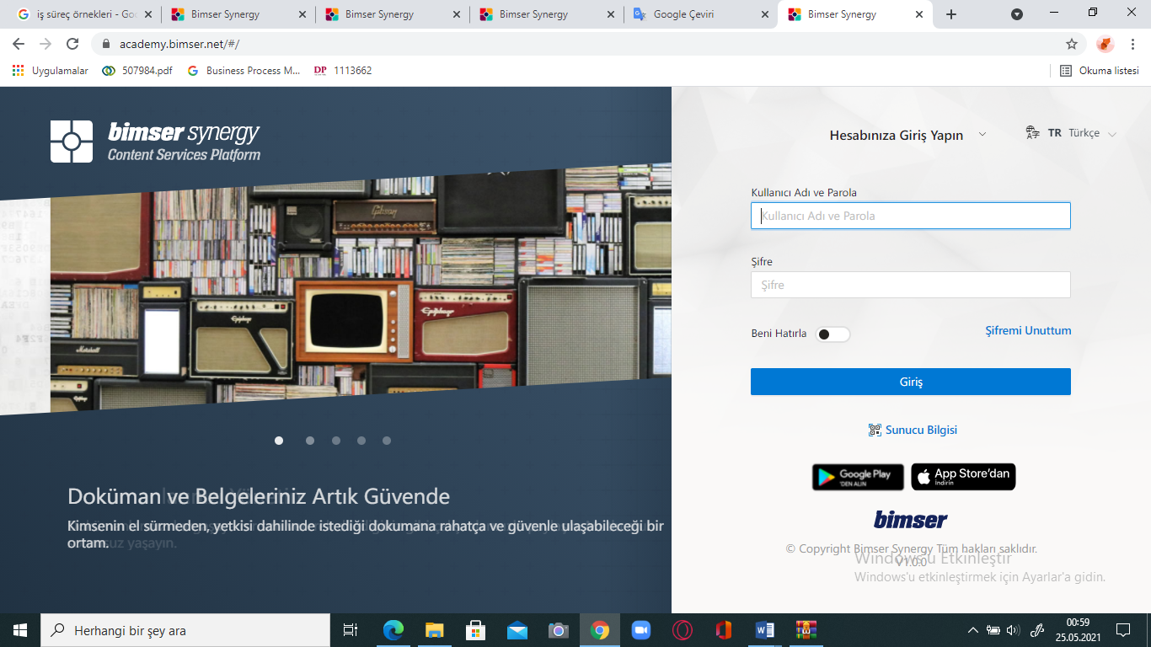

4.Main Page of Bimser Platform1

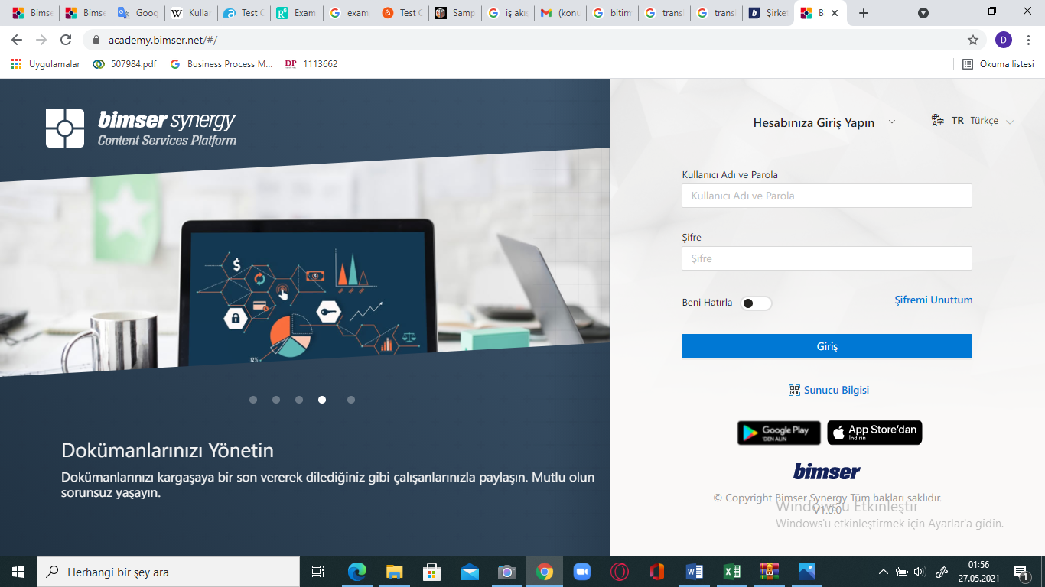

5.Main page of Bimser Platform

# SOLUTION APPROACH

## Flowchart of Project

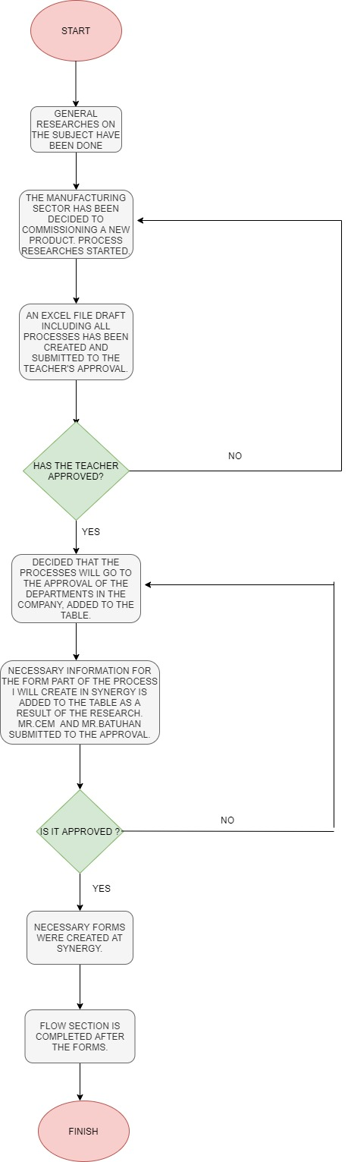

6.Project Flowchart

Immediately after the thesis topics were determined, a general and comprehensive research was conducted on Business Process Management and Workflow Management. A business process had to be addressed and the workflow of this process had to be designed. For the process management, it was decided to consider the process of commissioning a new product from the manufacturing sector. Production companies were going through many approval processes such as design, shaping, prototype production bidding.After collecting general information, the excel file included which process would be addressed, which departments to approve of these processes, which forms would be created on the system. Forms were created on it and supported with flow. The project process was thus completed..

## Project Steps With Gannt Chart

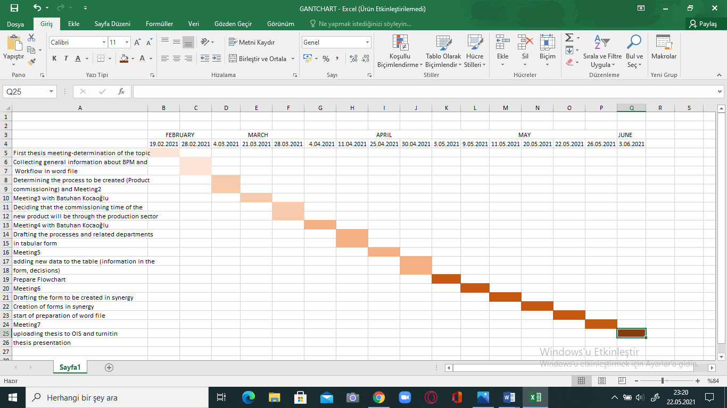

7.Project Gantt Chart

# SYSTEM DEVELOPMEnt process

## Installation of the required tools

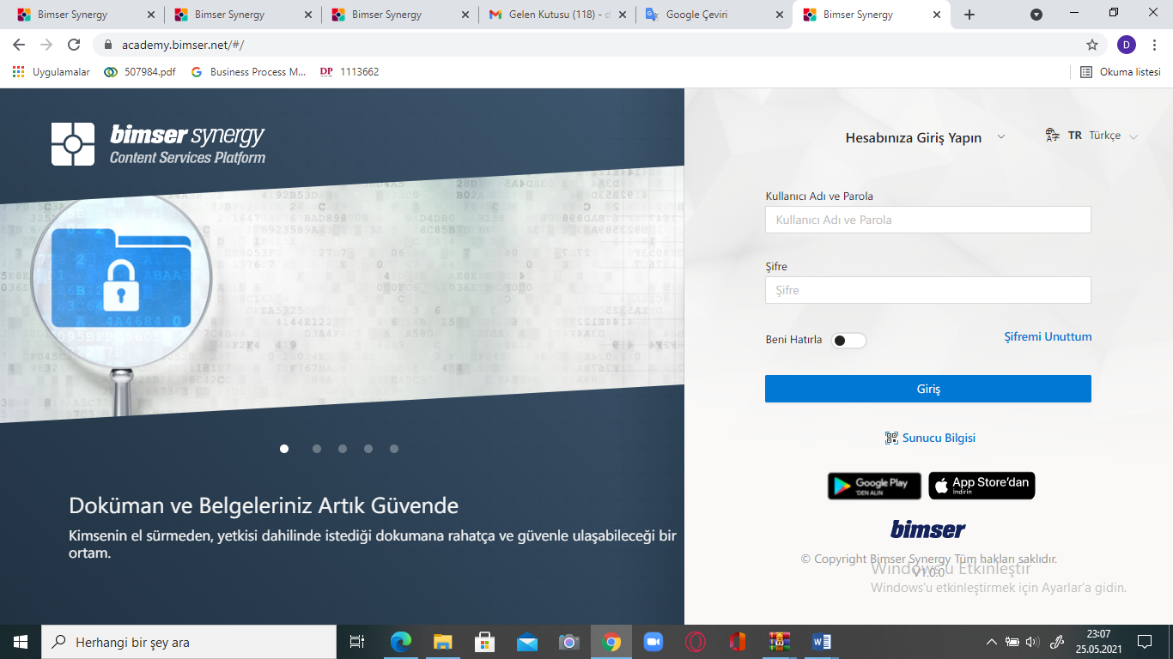

8.Start page of Bimser Synergy

By going to the academy.bimser.net/#/ extension, you can log in to the System with your username and password. You can prepare documents of business processes on the Bimser Synergy page without any installation on your computer, and also create your workflows.

## Development environments and processes

* First of all, the business processes of the new product deployment issue were prepared in MS Excel.

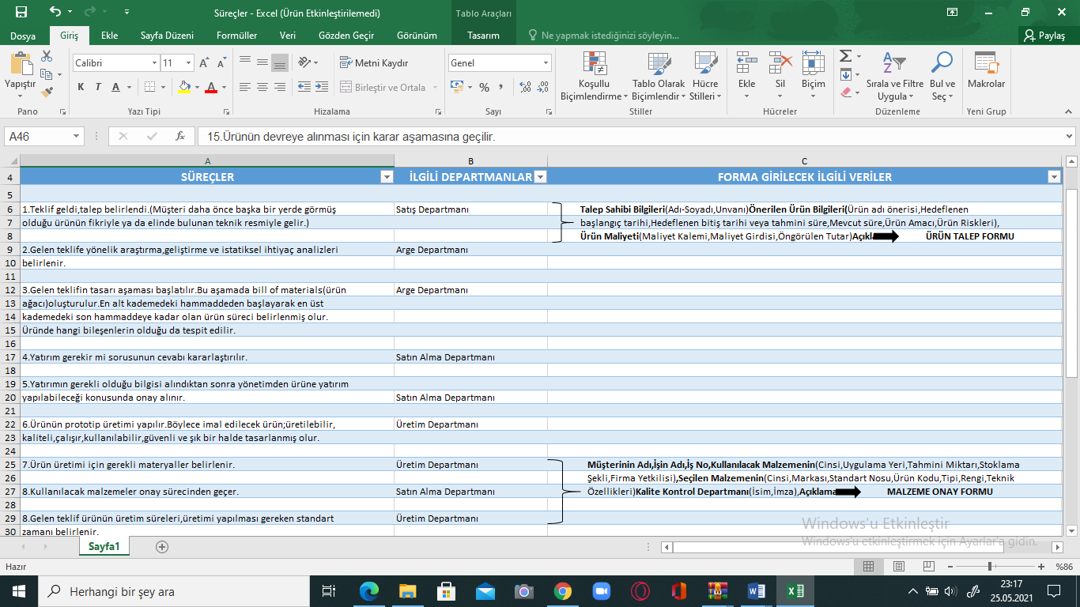

9.Excel draft1

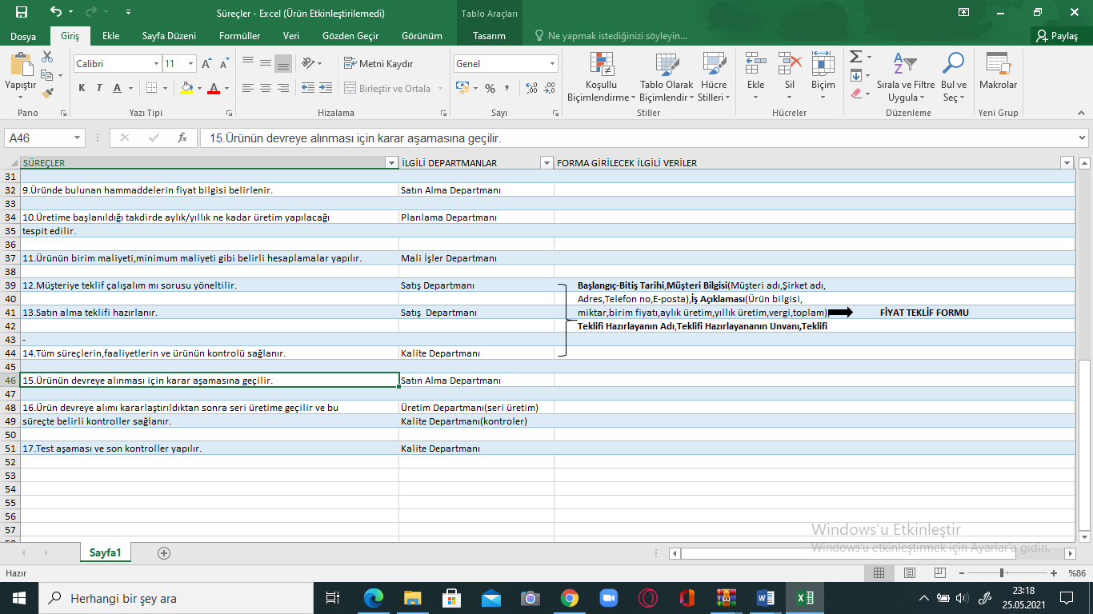

10.Excel draft2

* Departments in the company that are directly related to the processes are added to the table.

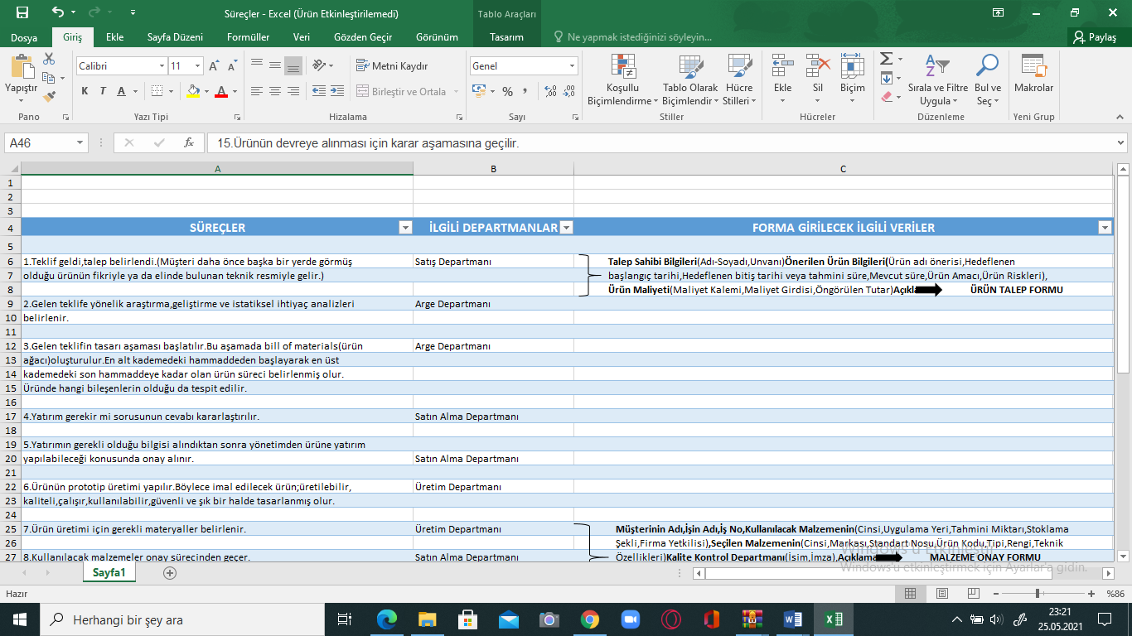

11.Excel draft3

* For the forms of the business process to be designed in Bimser Synergy, the data that must be entered in the form is finally added to the table.

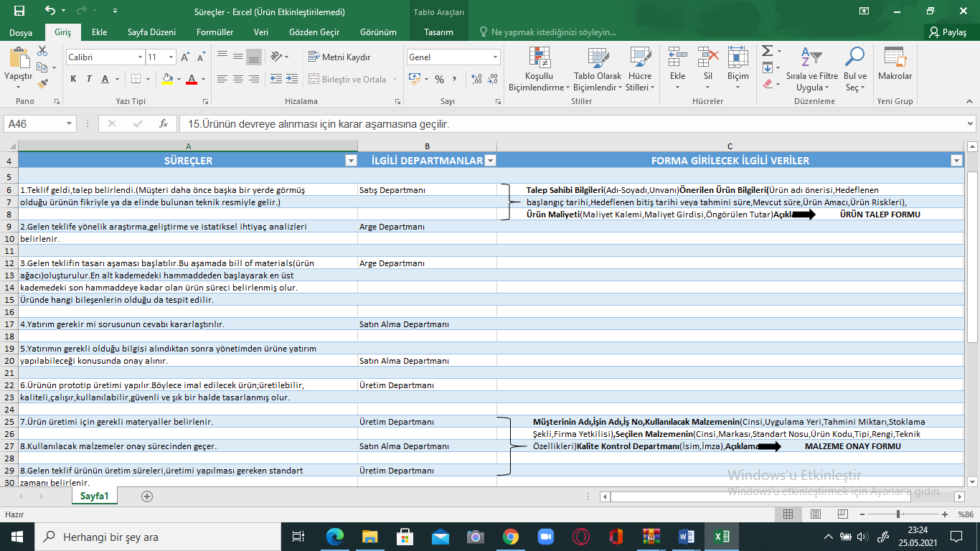

12.Excel draft4

* After completing the excel file where the processes are drafted, a flowchart containing the entire workflow is prepared. (Flowchart was prepared from the https://app.diagrams.net/ extension.)

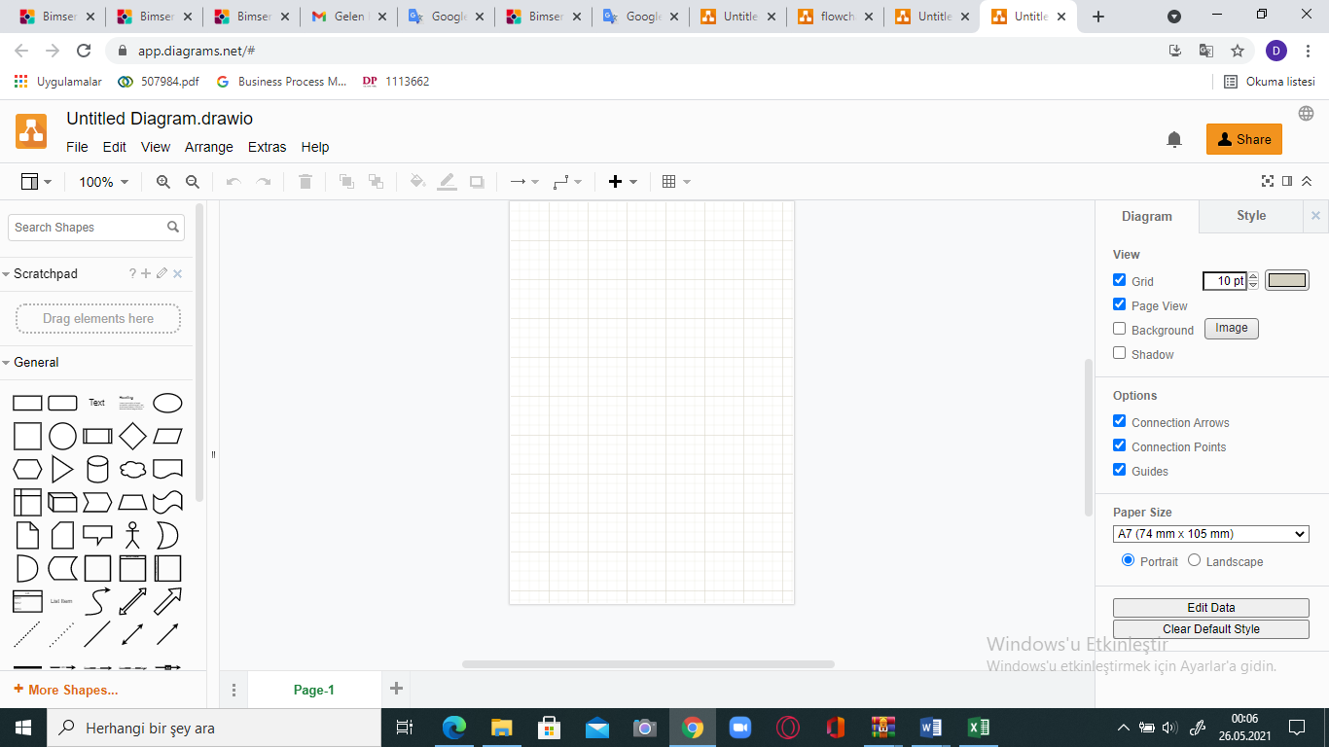

13.Create flowchart page

(Go to the Draw io page and start the design on the blank page.)

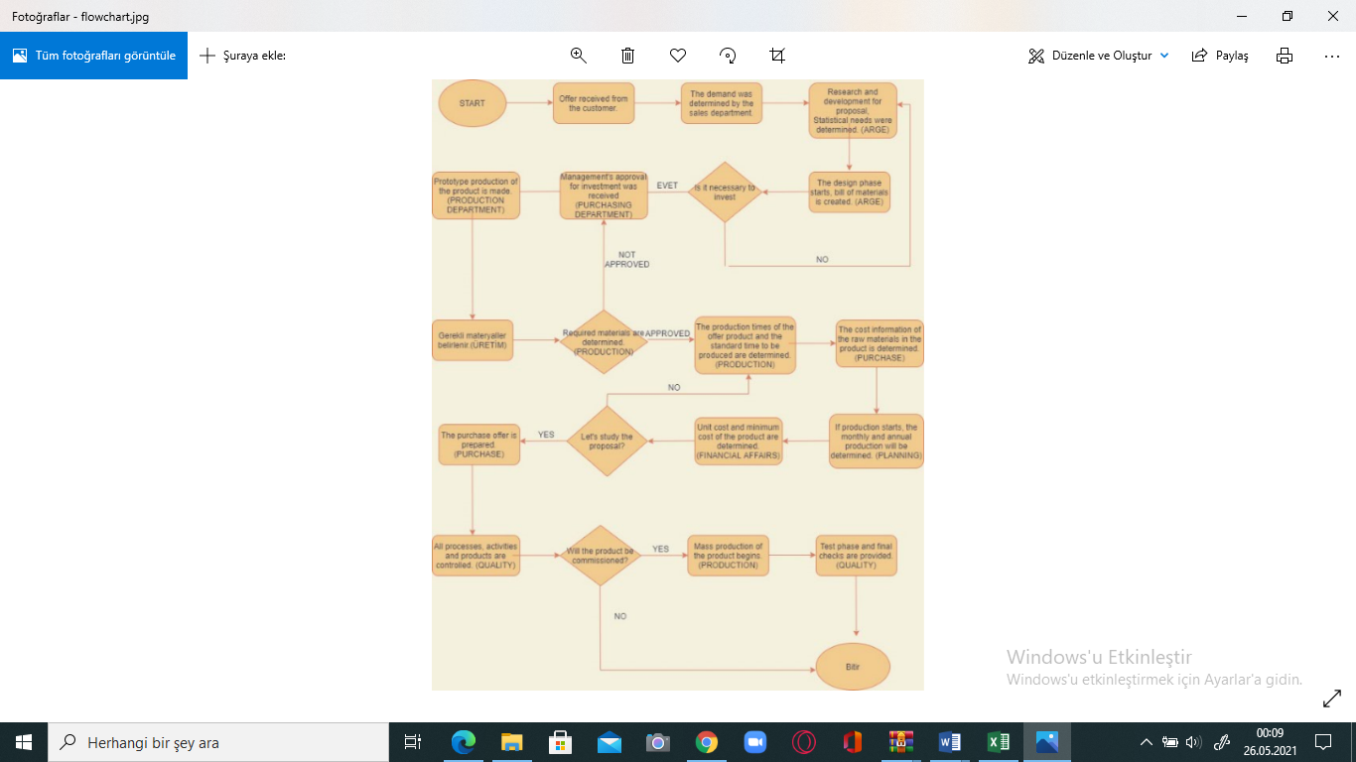

14.Flowchart of business process

* After these processes are completed, the Bimser Synergy (academy.bimser.net / # /) page is visited and the form design starts there to improve the business processes.

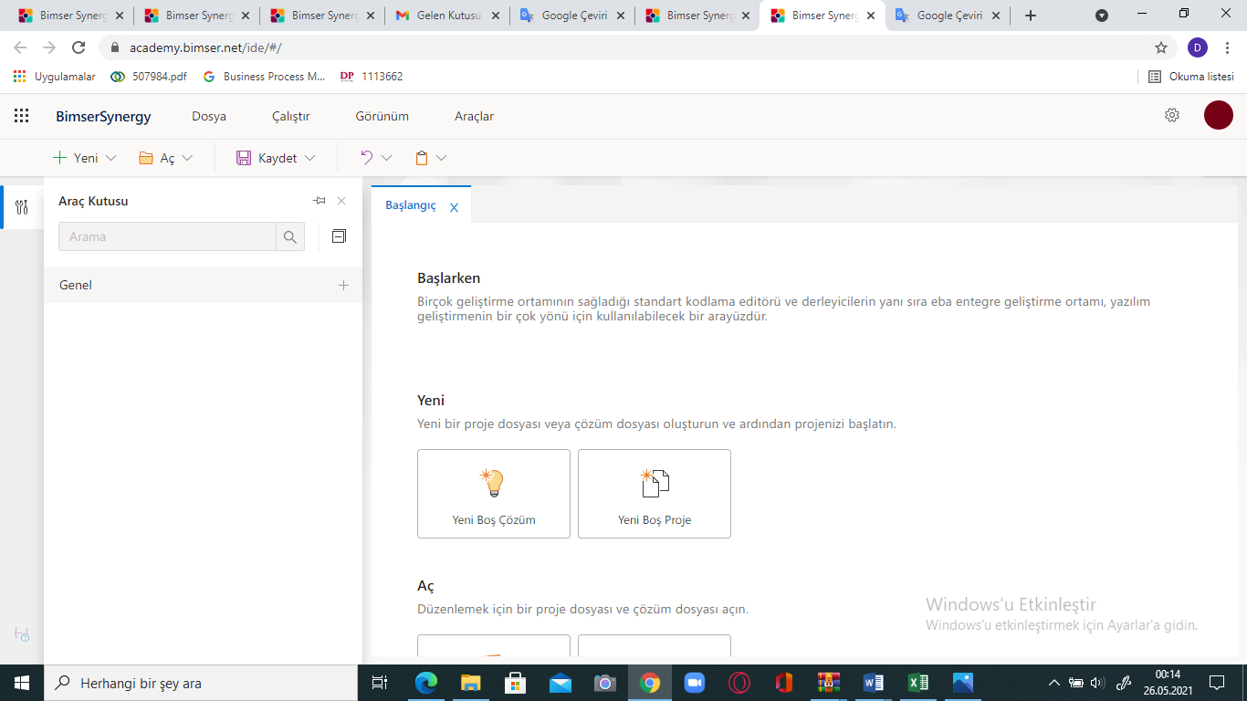

* The New Blank Project option is selected from the start page.

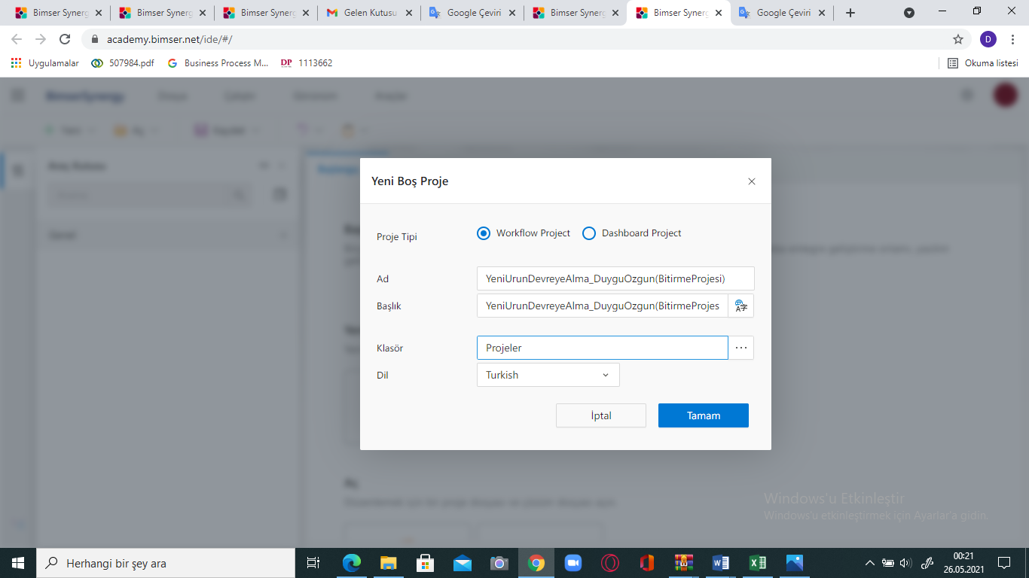

* After selecting the new empty project option, the name and title information is entered on the page that opens, and the folder in which we will save our project is selected.

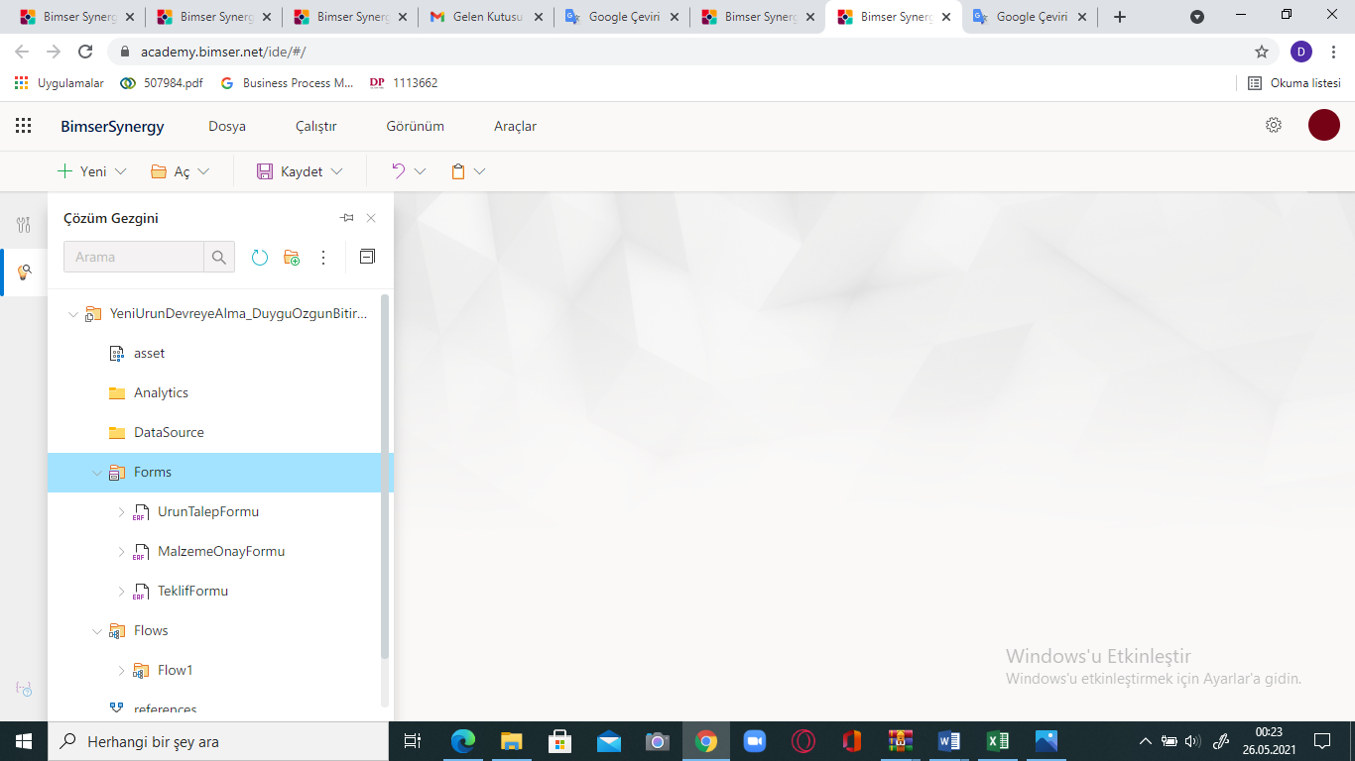

* After creating our project, the forms of the business processes are created from the Form Part on the screen that appears. After the forms are created, we create the workflow from the flow part.

# BUSINESS CASE

## Explaination implementation project

1. 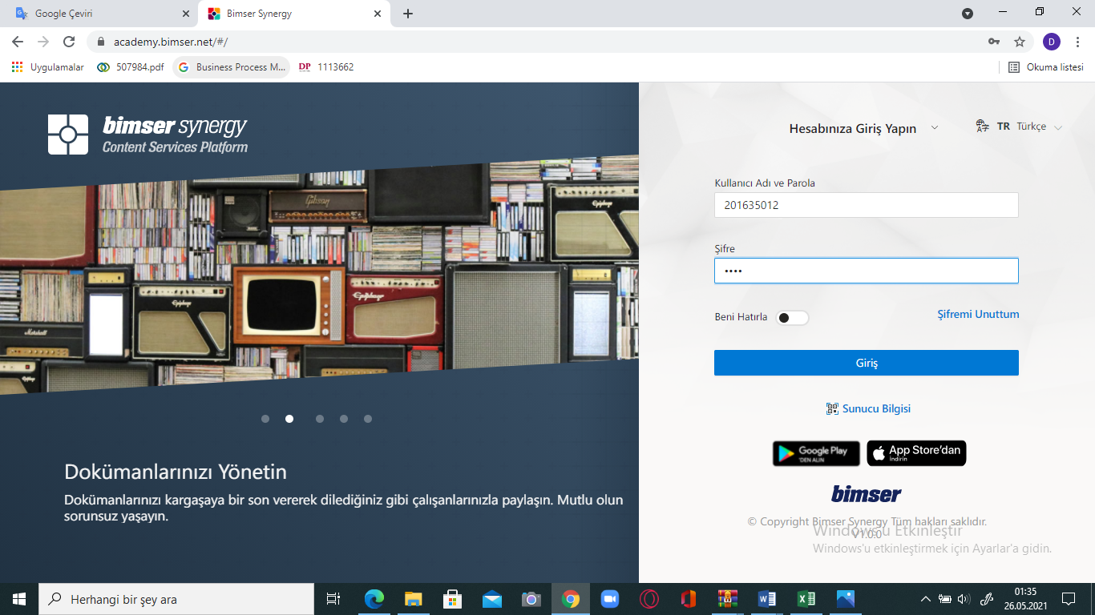 We log in to Bimser Synergy platform with our username and password in order to create the first step of the new product commissioning process in the production sector.

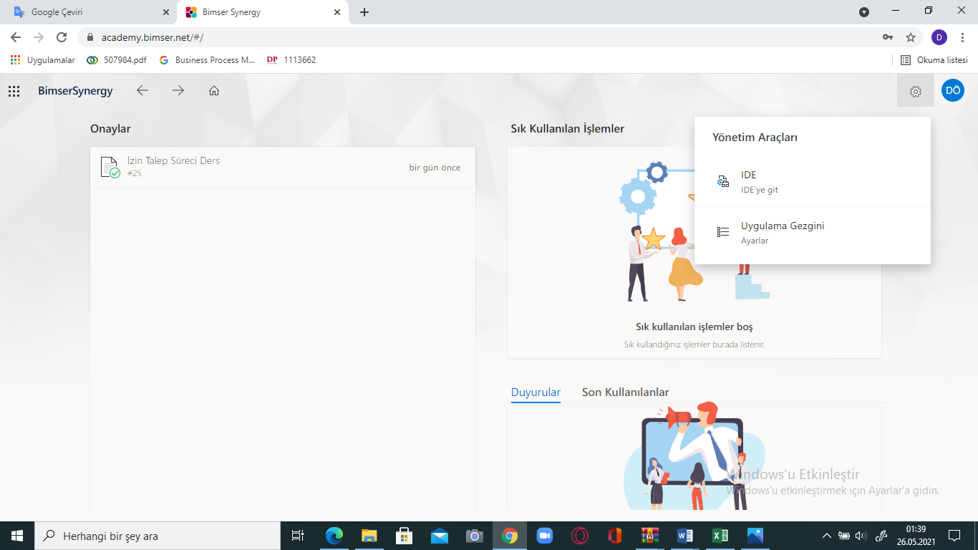

1. After logging in, we encounter a page like this in the system. By clicking on the management tools bar in the upper right corner, we are directed to the IDE page to start our project.

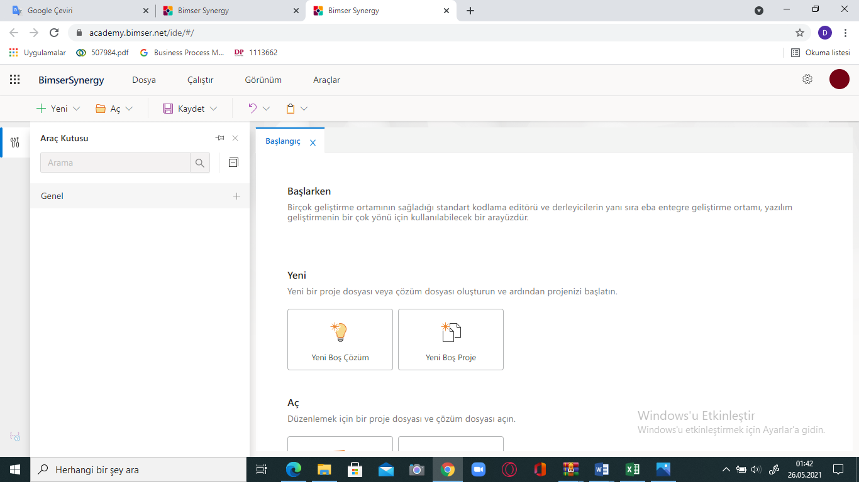

1. After saying "Go to IDE", a screen appears to create our project. On this screen, we select the New Empty Project option from the "New" section.

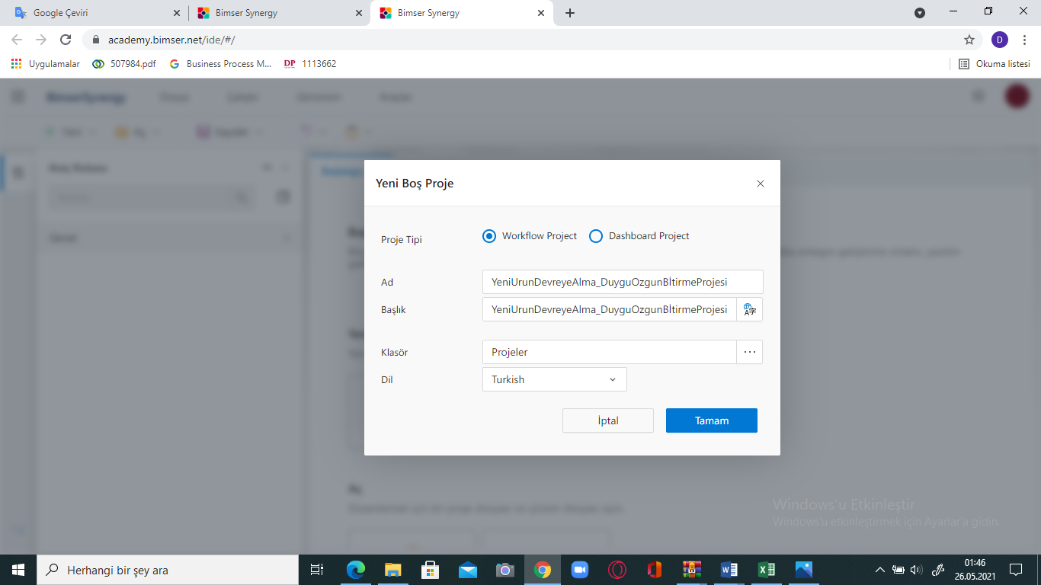

1. In the New Empty Project section, we choose the project type as workflow project, because the project we will do will be a flow project. Then we decide on the name of our project and choose the location where we will save it from the folder section. We should be careful not to use Turkish characters while naming. After saying OK, our project page is created.

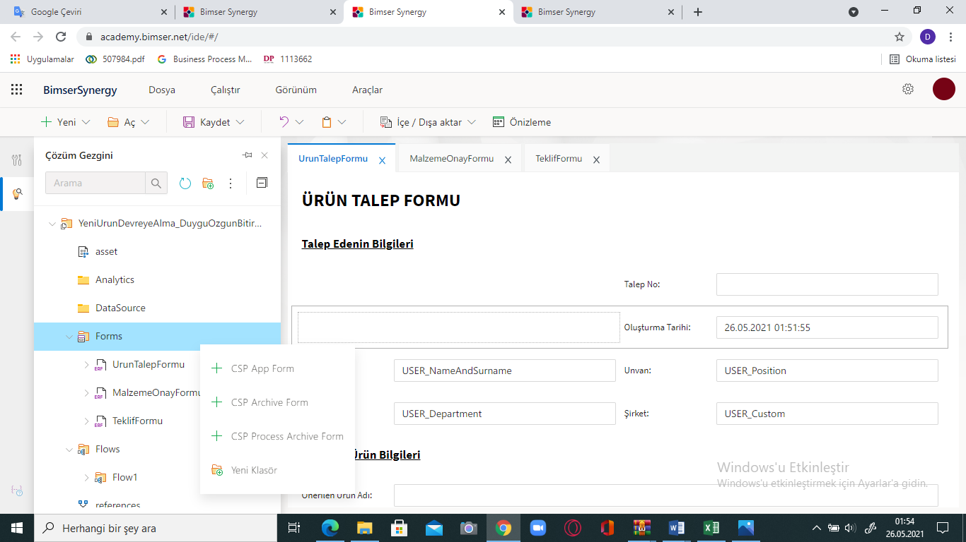

1. We create a new form page from the CSP App Form by right-clicking the Forms section from the solution navigator panel on the left of the screen that appears. Because the customer's coming and saying to the purchasing department that I want the production of this product causes certain business processes and the first process starts with the demand of the product.

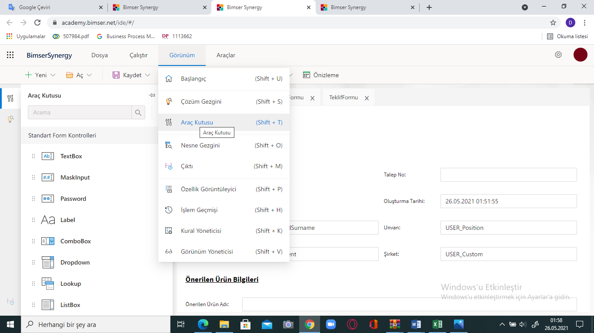

1. When starting the design of the form, the Toolbox is opened from the view tab. Various form objects are used here to create the form.

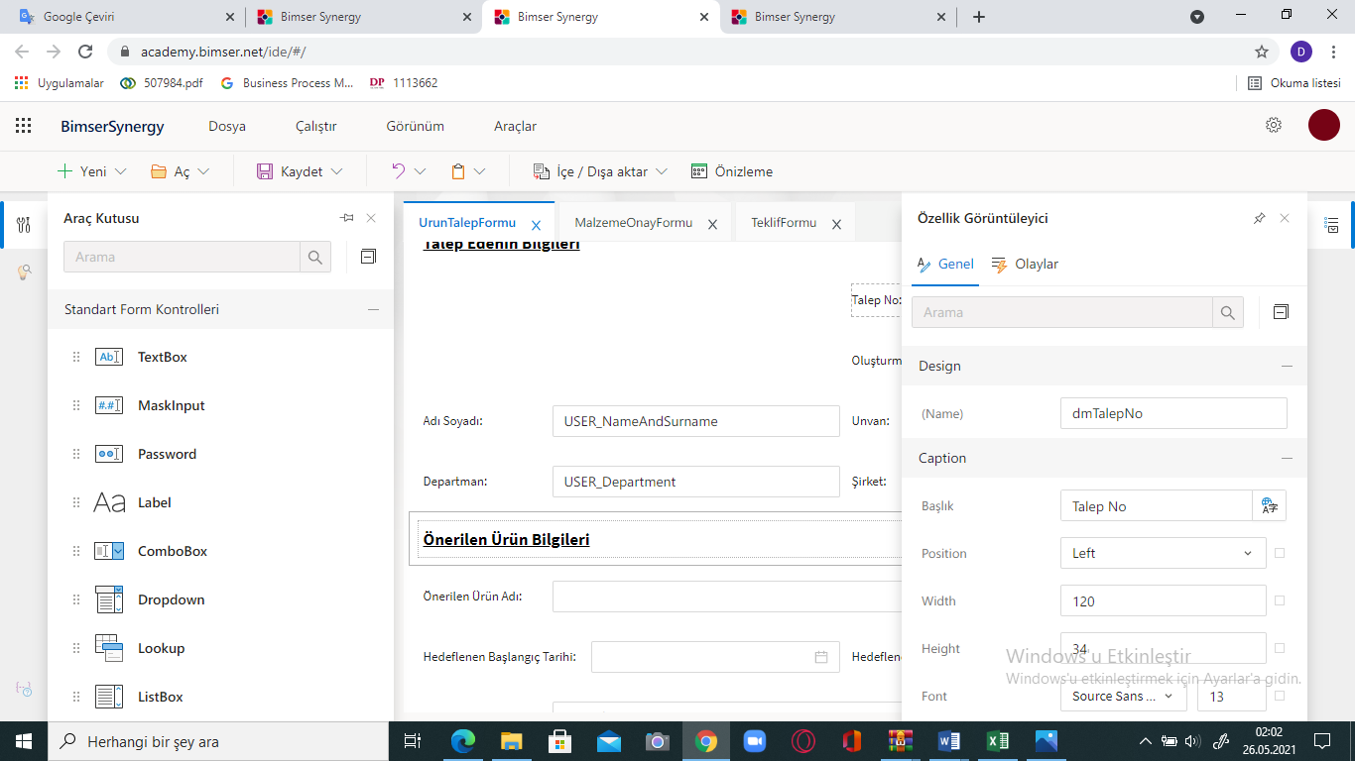

1. The tool to be used with drag-and-drop feature is taken from the toolbox and left in the layout in the page. When we click twice on the object we left, the property panel of that object opens and the Name field is changed from the design part of this panel. In the Caption section, we can change the name of the objects in the form with whatever name we want. Fonts can be adjusted from this section in properties such as height and width. From the Appereance section, we can make adjustments such as whether the object will be visible or not.

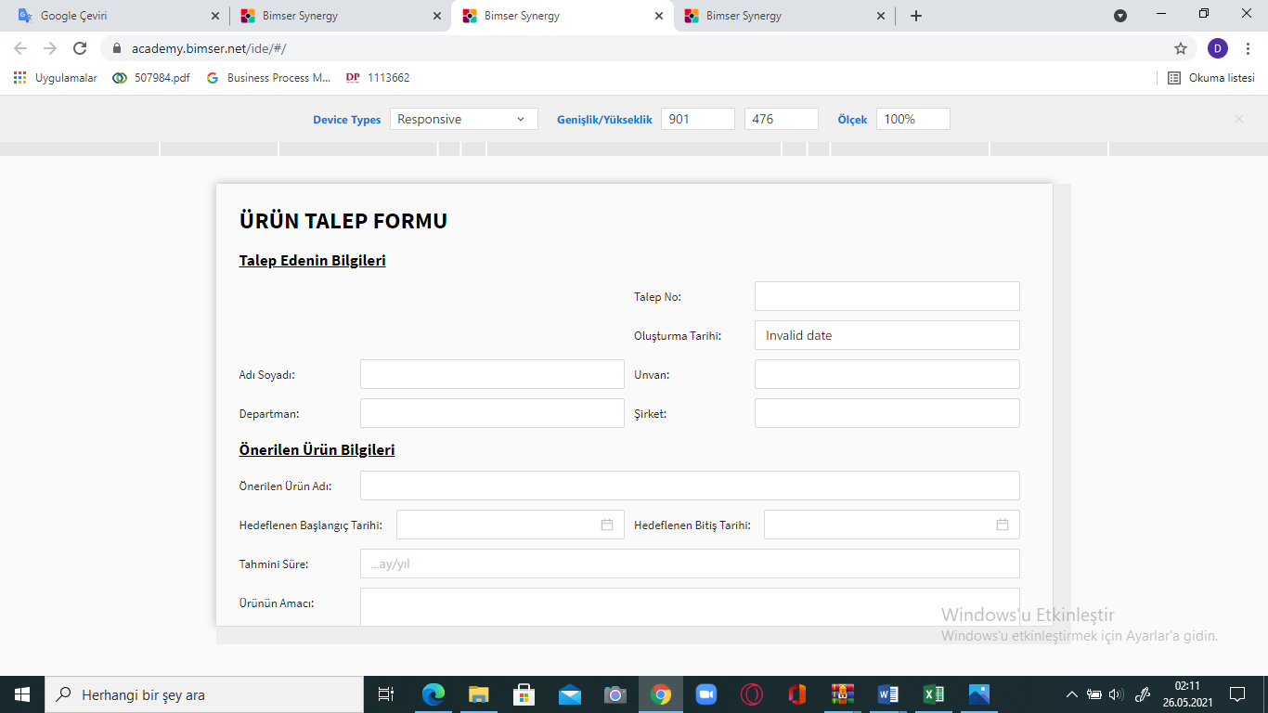

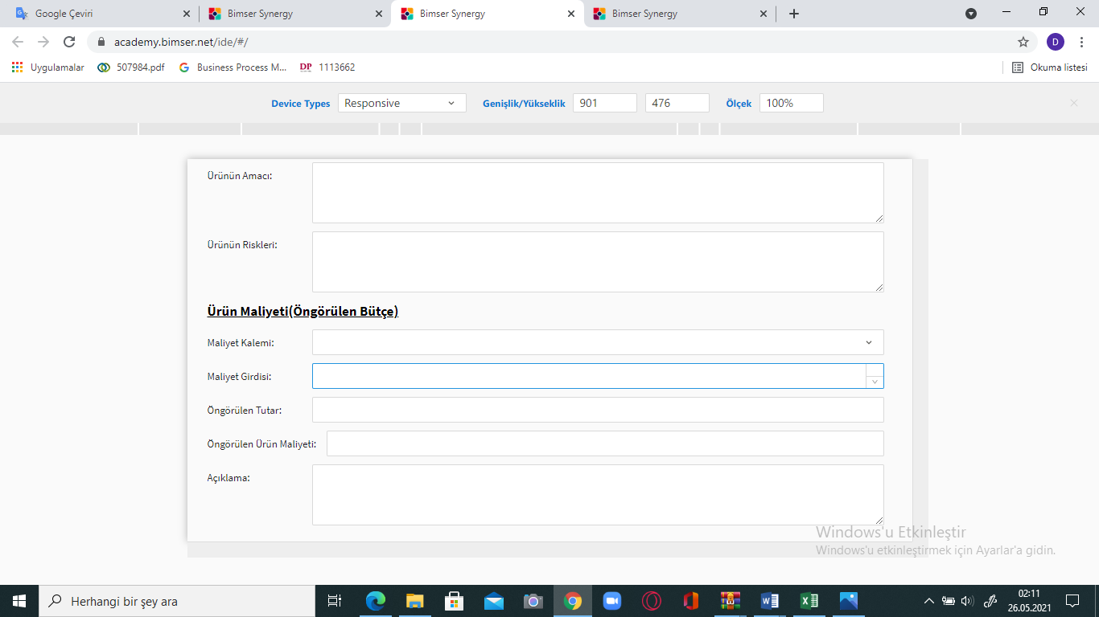

1. **The Content Properties of the Objects I Created in the Product Request Fo0rm**

**(product request form)**

**Request No:** The field where the document number to be automatically generated by the company is displayed. It cannot be changed.

**Creation Date:** The date the form is created will be brought automatically. It cannot be changed.

**Name Surname:** The product will be brought automatically depending on the person requesting it.

**Title:** The product will be brought automatically depending on the person requesting it. It cannot be changed.

**Department:** The product will be brought automatically depending on the person requesting it. It cannot be changed.

**Company:** The product will be brought automatically depending on the person requesting it. It cannot be changed.

**Product Name Suggestion:** It is a text type field to be entered manually. It cannot be changed.

**Target Start Date:** It is the field where the date will be selected.

**Targeted End Date:** It is the field where the date will be selected.

**Estimated Time:** It is a number type field to enter maneul.

**Purpose of the Product:** It is a text type field to be entered manually. Entry is required.

**Product Risks:** It is a text type field to be entered manually. Login is required.

**Cost Item:** It is a single-selection field. Its content will be defined as indirect material auxiliary, operating materials, indirect labor materials, depreciation expenses of fixed assets used in production,

insurance, tax, fee and rental expenses of fixed services used in production, energy and fuel expenses, service expenses.

**Cost Entry:** It is a number type field to be entered manually. Entry is required. Number entry can be made with a comma.

**Projected Amount:** It is a number type field that will be entered manually. Entry is required. Number entry can be made with a comma.

**Projected Product Cost:** It is a number type field that will be entered manually. Entry is required. Number entry can be made with a comma.

**Description:** It is a text type field to be entered manually. Entry is required.

(This form is prepared by the purchasing department to start the process and the process is submitted for the approval of the relevant departments. In the flow section, the form is first submitted to the purchasing manager for approval. If the purchasing manager approves the form, a quotation is prepared for the product. A form is designed for the materials to be used in the production of the product and their costs and the whole process is submitted for the approval of the relevant units in the flow. It is also submitted to the approval of the financial affairs officer, administrative affairs officer, senior management and the general manager. As long as the approvals proceed within the pink route, the process is completed and the product is put into operation.)

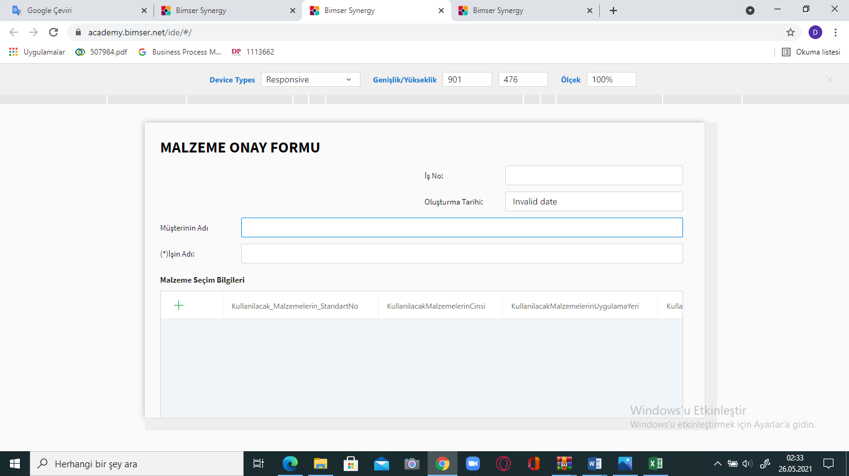

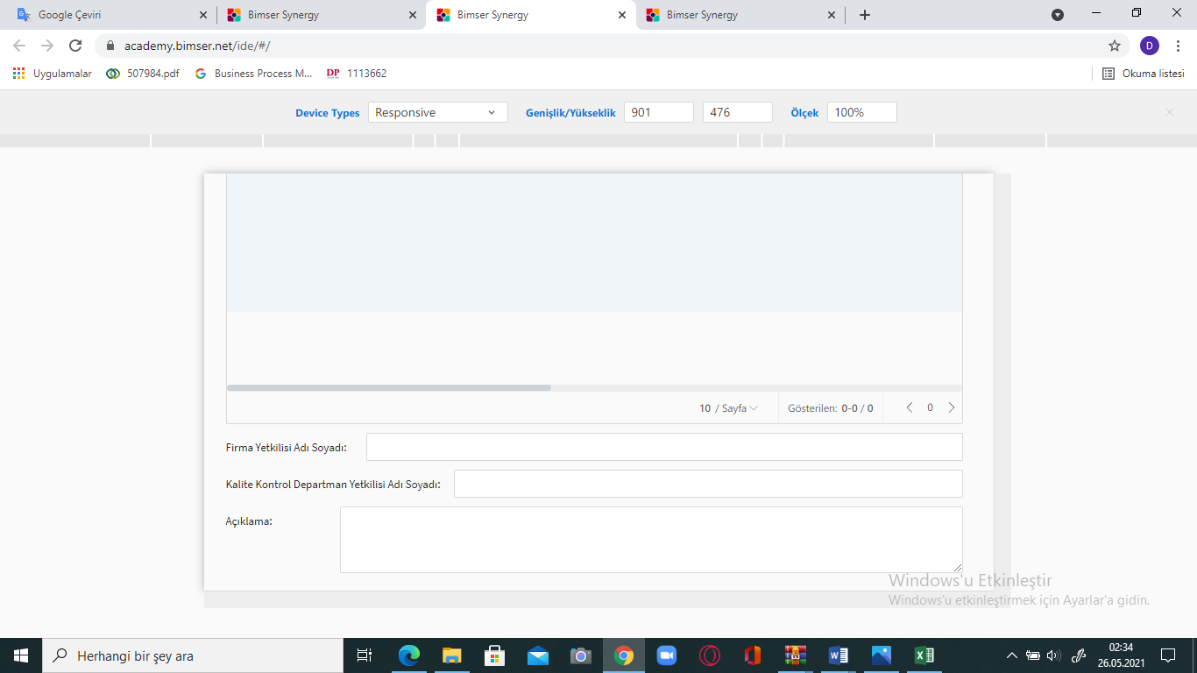

1. **The Content Properties of the Objects I Created in the Product Request Form(Material approval form)**

**Work No:** The field where the document number to be automatically generated by the company is displayed. It cannot be changed.

**Creation Date:** The date the form is created will be brought automatically. It cannot be changed.

**Customer's Name:** The form will be brought depending on the person requesting it.

**The Name of the Job:** It will be fetched automatically. It cannot be changed**.**

**Material Selection Information:** It is the section that will be created as a table, where the information of the materials will be entered. Data to be added to the table; The type of materials to be used, the place of application, the estimated amount, the way of stocking, the product code, type, color and technical properties of the materials.

**Company Official Name Surname:** The product will be brought automatically depending on the person requesting it.

**Quality Control Department Authorized Name and Surname:** The product will be brought automatically depending on the person requesting it.

**Explanation:** It is a text type field to be entered manually. Entry is required.

(After the Product Request Form is approved, the Material Approval Form is sent to the Responsible of the Production Department. In this form, the information on the materials to be used for the purpose of this form allows the departments to control the business process.)

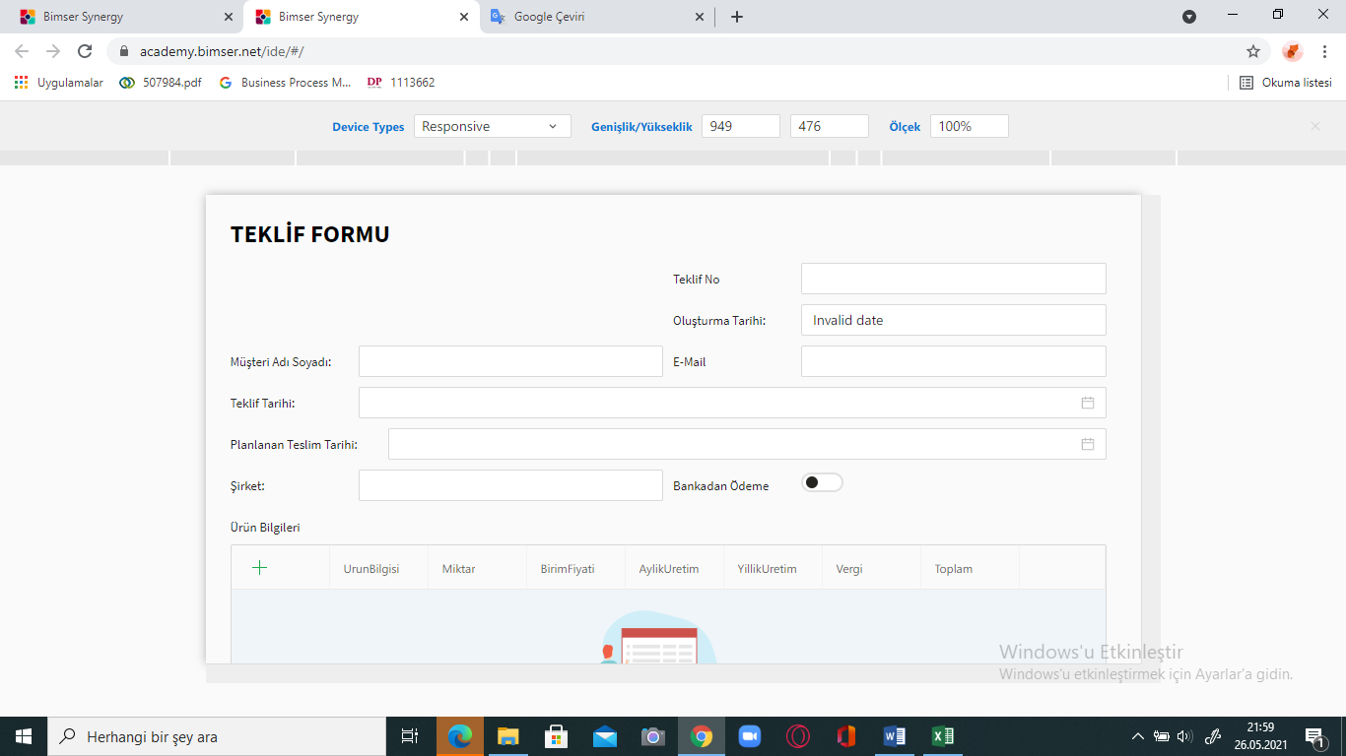

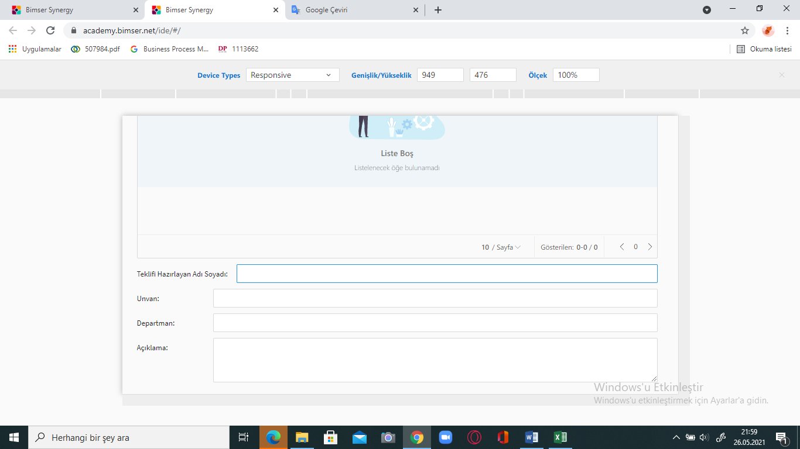

1. **The Content Properties of the Objects I Created in the Product Request Form**

**(Proposal Form)**

**Offer Number:** The field where the document number to be automatically generated by the company is displayed. It cannot be changed.

**Creation Date:** The date the form is created will be brought automatically. It cannot be changed.

**Customer Name Surname**: It will be fetched automatically. It cannot be changed.

**E-mail:** It will be fetched automatically. It cannot be changed.

**Order date**: Date is the field to be selected. Past dated transactions cannot be made.

**Planned Delivery Date:** Date is the field to be selected. Past dated transactions cannot be made.

**Company:** It will be fetched automatically. It cannot be changed.

**Bank Payment:** This is the field to be marked when the payment is requested to be made to the bank.

**Product Information:** It will be created as a table. Data to be added to the table are product information, quantity, unit price, monthly-annual production, tax and total.

**Name and Surname Who Prepared the Offer:** It will be brought depending on the personnel who started the flow. It cannot be changed.

**Title:** It will be brought depending on the personnel who started the flow. It cannot be changed.

**Department:** It will be brought depending on the personnel who started the flow. It cannot be changed.

**Explanation:** It is a text type field to be entered manually. Entry is required.

(During the product commissioning process, a question is asked to the customer whether to study a proposal. After receiving a yes answer from the customer, a proposal form is prepared by the purchasing department with the necessary price information of the product and this offer form is presented to the approval of the customer.)

1. **Creating the workflow of the process after the forms covering the business processes are completed**

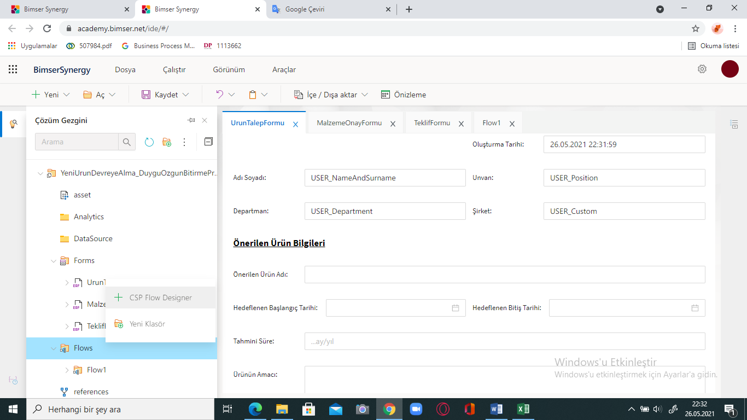

* After the forms are created, workflow design is started by right clicking the Flow section in the solution explorer panel and opening a new flow page from CSP Flow Designer.

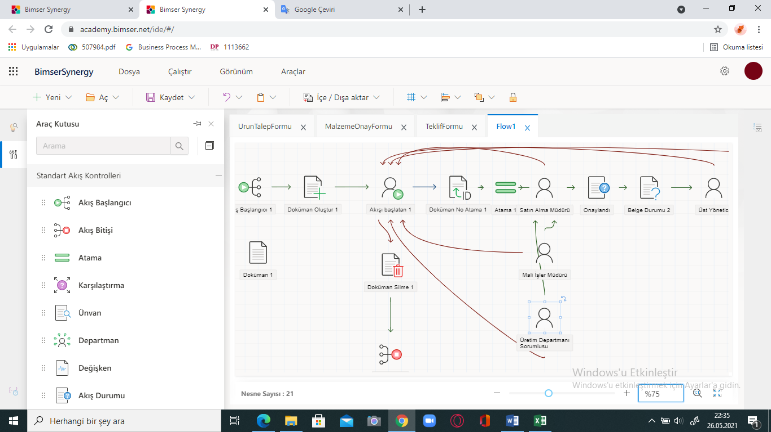

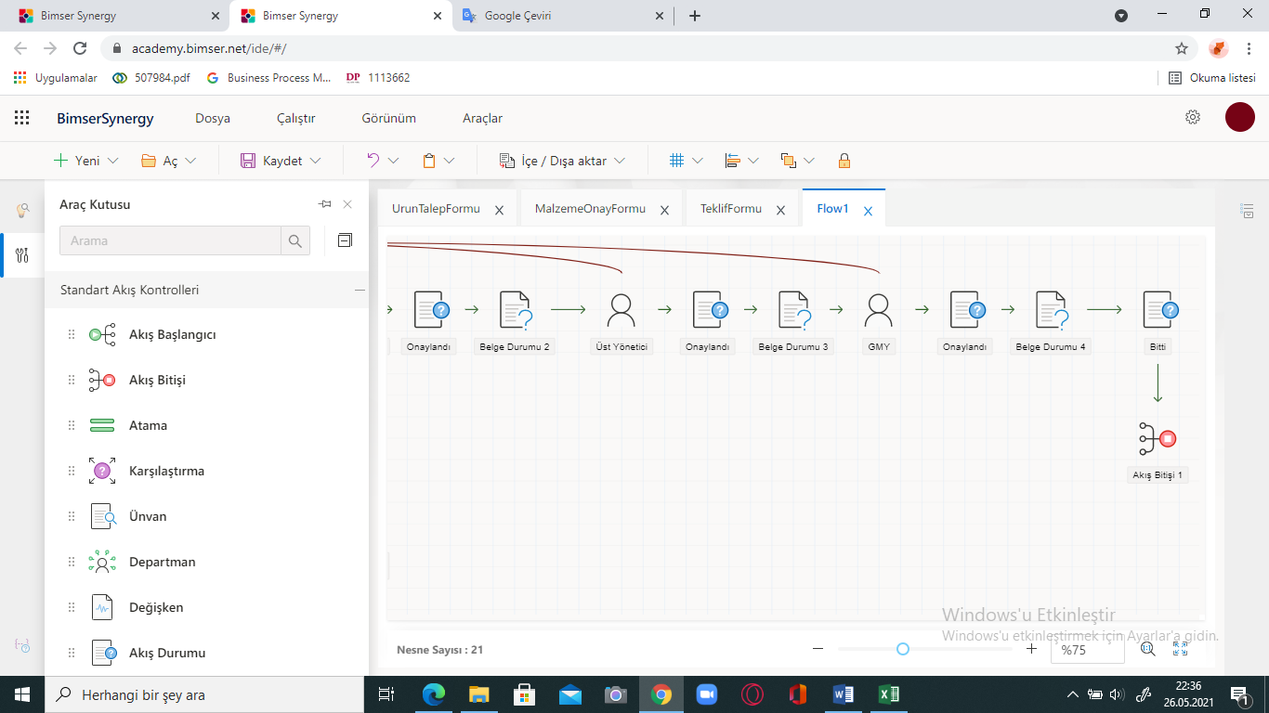

• While creating the flow part, there are some objects that we will use in the tool panel. Flow starts first with the flow start object, then use the object that started the flow and double click on this object to set its properties.

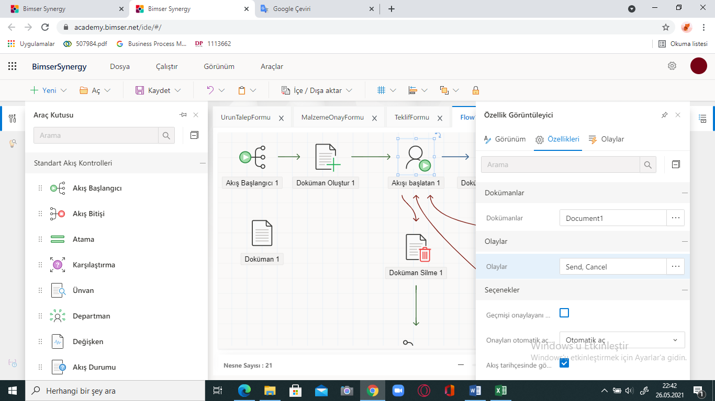

• In the properties of the stream initiator, the events part is selected as ‘send and cancel. Once the properties of the flow starter are set, the flow continues with the assignment object. The assignment object ensures that the document in the flow is forwarded to the relevant responsible persons in multiple departments.

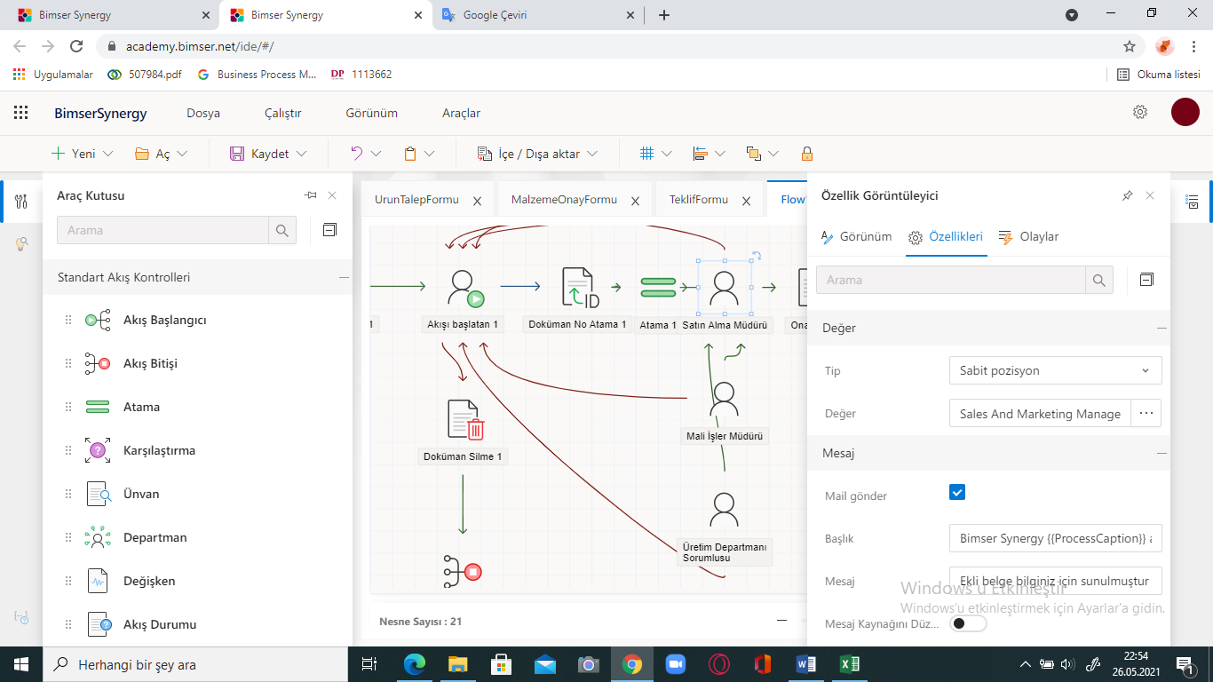

* After the assignment object takes its place in the flow, the principals to which the relevant forms will go are added to the flow by using the position object. After double clicking on the position object, Type and Value settings are made from the properties window. Here, the type is selected as the fixed position and the value is selected as the head of the relevant department.

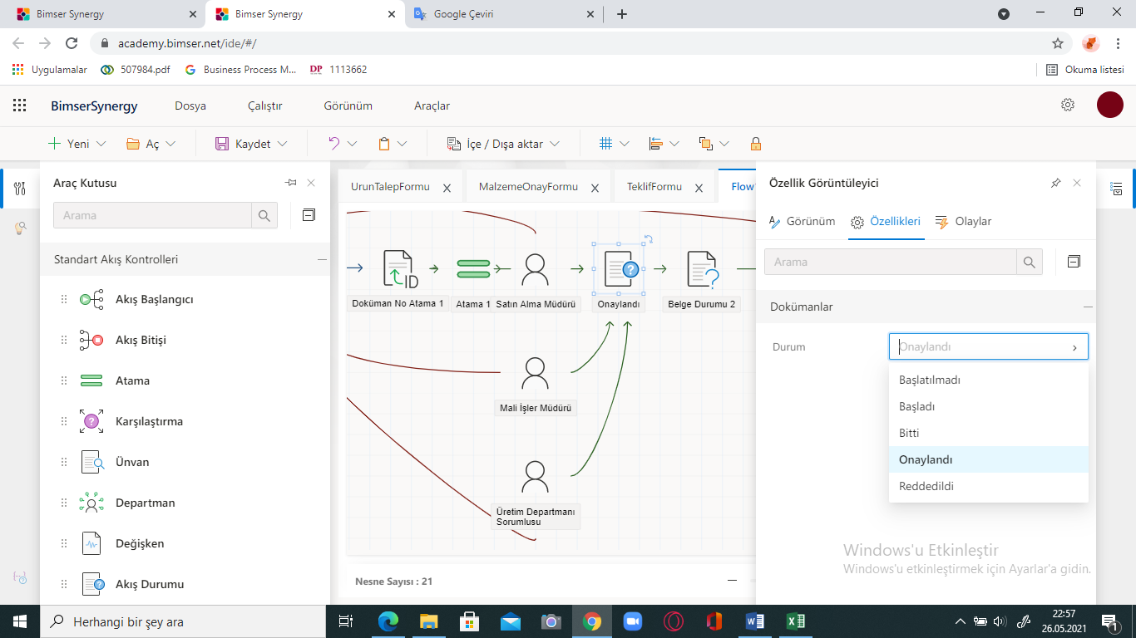

• After the position objects have completed their place in the flow, if the custodians approve these forms, the process continues with the addition of the document status object. Status is set to Approved in the properties window of the document status object.

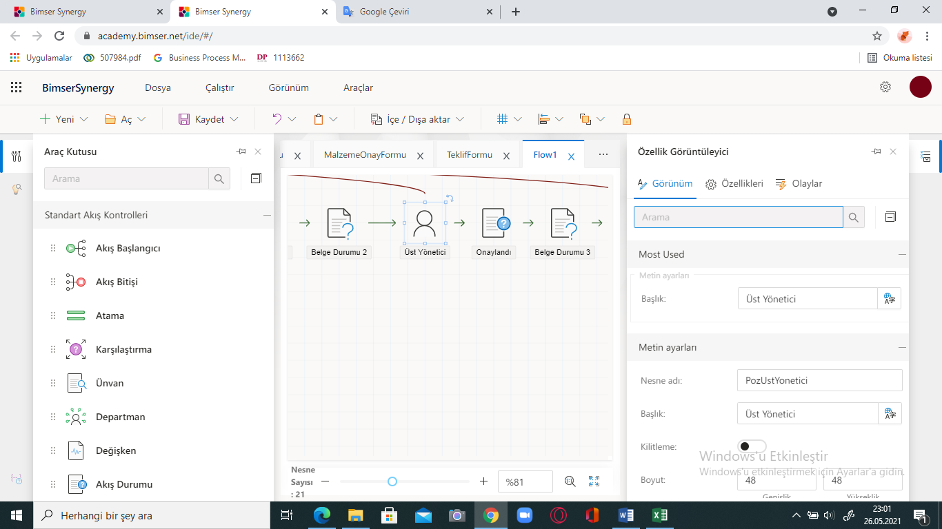

• If the certificate status continues as approved, the process continues with the approval of the Senior Management. The Position object is added for the approval of the senior management and the necessary adjustments are made in the Properties section. If the Senior Management approves, the document is sent to the General Manager this time, and as a result of his approval, the process is terminated by adding the flow finished object.

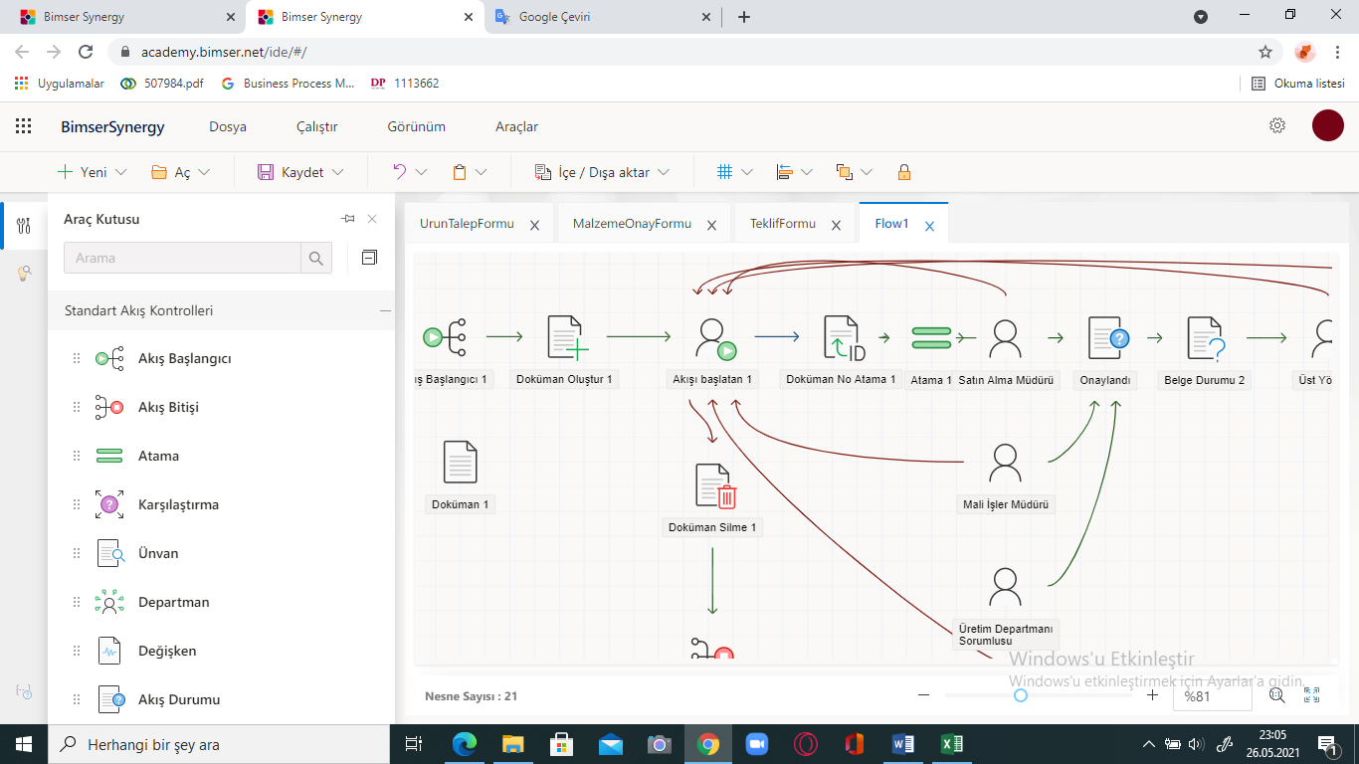

• If any of the relevant positions does not approve the flow, the process is directly rejected and forwarded to the flow initiator.

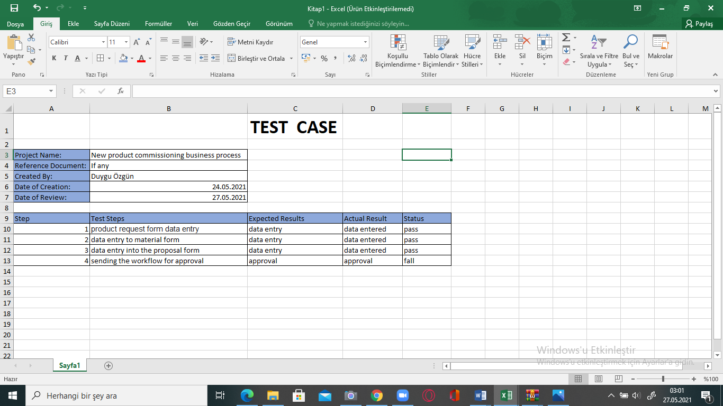

15.Test-case diagram

# CONCLUSION

## Advantages of Project

**1. Risks reduction**

Because of the changing [business environment](https://softwarehut.com/blog/category/business/), companies are prone to organisational errors that may affect their efficiency.

Having a [BPM tool](https://softwarehut.com/blog/business/bpm-software-examples/) allows management to monitor resource utilisation, which is a typical workflow for different processes and their execution. Managers can also spot inefficiencies early on to reduce costs or improve resource allocation.

**2. Better organisational control**

Moreover, with reduced risks comes [improved organisational control](http://www.usccg.com/blog/how-can-a-management-operating-system-help-your-organization/), as management has better knowledge of what works at the company.

Such is often the case in mid-sized to large companies, with many departments and even several office locations. Here, setting processes to be followed by all employees is crucial to running a business effectively. A BPM tool makes controlling these processes more manageable.

**3. Optimised processes**

Thirdly, with an overview of the [operations](https://softwarehut.com/blog/business/energytech-energy-industry/) at the organisation, managers can optimise those that are inefficient or revealed to be outdated.

The benefit of a BPM tool, in this case, comes down to how easy it can be to create new processes or improve the existing ones with such software. As a majority of modern tools offer drag-and-drop visualisation features, it takes less time to [optimise processes](https://www.kizeo-forms.com/en/optimize-your-processes-with-digital-forms/).

**4. Increased agility**

The ease of adjusting business processes is crucial, as businesses try to improve their coordination. Especially today, with [digital transformation](https://softwarehut.com/blog/business/digital-technologies-advance-business/) changing various industries, this need to be able to easier adapt to changes is now more easily seen.

**5. Improved collaboration**

Many businesses face a problem of communicating processes across departments or offices. This, as a result, impacts on collaboration in an organisation.

With BPM tools, processes can be communicated more clearly, as their visualisations are available to everyone. Whenever someone is looking for a peer responsible for a specific part of the process, they can find them by following the process in the tool.

**6. Workflow automation**

Using BPM tools, managers can manage multiple [workflows](https://tallyfy.com/workflow-process/)to decide which one could be automated. This approach can free up some resources, so they can be re-assigned elsewhere to boost the company’s productivity.

Automating workflows can also cut the cost of some operations. As with AI advancements, it is possible to reduce many manual processes.

**7. Ensured compliance**

Many of the procedures followed by organisations have to be compliant with methodologies and norms like ISO. Otherwise companies can receive diminished ratings, withdrawn certificates, or even financial penalties.

BPM tools make it easier to manage processes, so they fit these norms, as well as provide a background for both internal and external audits.

**8. Overview of organisational goals**

Very often employees don’t follow processes, because they can’t see the bigger picture behind them, or how they correspond to their duties and organisational goals.

Mapping processes for the entire organisation and sharing this overview with employees makes it more apparent how they transcribe to the business goals of a company.

**9. Employee happiness**

Finally, clear objectives, processes, and responsibilities make for happy and satisfied employees. Team members who work in workplaces with clear structures are more productive and happier, because they don’t call into question their assigned tasks.

BPM tools help create transparent processes and documentation that allow employees to make sense of changes at their employed organisations. (softwarehut, 2020)

## Advantages and drawbacks in the projects

• In the project, the entire process that the new product commissioning process will follow within the company was designed in forms and documented in digital environment. Thus, the process has been transferred to digital environment, saving time to be spent.

• The start of the process is approved by the form that appears on the screen of the relevant department in digital environment and is easily sent digitally for the approval of the other unit.

• With the created work flow, business process efficiency is achieved.

• The workflow created during the new product commissioning process provides the participants with direct information about the case they are related to, without the need for any intermediary.

• Workflow provides automatic assignment of jobs to participants based on defined rules.

• The cost inputs filled in the product request form created provide the relevant department to have an idea about commissioning the product, and if the inputs are found appropriate, the approval phase is provided for the commissioning of the product.

• New product commissioning is a process that requires many approvals within the company. The approval forms and work flow in the application make the process run faster and cleaner.

## Difficulties encountered in the project and their solutions

One of the biggest difficulties I faced in the project was that I could find very little information on the subject I chose from the internet and books. Although there is a lot of information about business processes and work flows, unfortunately I could not find enough information about business processes for a new product to be commissioned in the production sector. The subject I chose was a process that had to be approved by many departments, and I had to master all of these departments along with the processes to be followed. Although I could not find much as a result of my search for sufficient information, I ensured the formation of a general draft in my mind with the help of Batuhan in the meetings with our consultant teacher that took place every two weeks. Another part I struggled with was the part where I had to design the flow of the processes after the forms I created on the Synergy platform. The process involved a bit of confusion as to how I should follow the flow, as it involves many departments. The fact that there are many objects and many properties of these objects for workflow in Synergy made things more complicated for me. I tried to solve this problem in line with the feedback received by Mr. Cem and Mrs. Aleyna, who gave us the Modern Corporate Systems and Software course at Bimser Synergy for a period of time.

## Possible improvements for further studies.

If we want to move the project further, we can make some improvements. For example, there may be more than one missing data in the forms I created in Bimser Synergy. More, relevant data can be added to the content of the forms. The created forms are not limited to product request forms, material forms, and offer forms, but forms that require further approval can be designed. Missing and wrong parts of the workflow can be improved and made more comprehensive and understandable.

## Similar project explanation

I came across a project similar to my project in the Modern Enterprise Systems and Software course we took during the semester. The project conducted in the course was a Permit Request Form designed in Bimserde Synergy. The process initiated by a customer requesting permission within the company concerned many departments within the company. The study that covers these processes started with the form in which the personnel requesting leave filled out various information under the heading Permission Request Form at Synergy. (Name, title, department of the person requesting leave, the date on which the leave started, type of leave…) Later, the completed form was forwarded to the top manager of the personnel, if the top manager approved, the form was forwarded to the human resources and then to the deputy general manager by the system for approval. If all of the people in the relevant department approved this business process in digital environment, the leave request of the staff was accepted and they could go on leave on the requested dates.

## Project contributions

The project showed me how business processes and workflows can be improved electronically. Before, I always looked at the workflow with a technical picture, so I could not have the opportunity to develop in the system. I learned that companies need to go through many processes before they decide to manufacture a product and that these processes are related to more than one department. I got general information about business processes and what work flow is. First of all, I had the opportunity to practice the process and flow management, which I prepared in excel as a draft, on the Bimser Synery platform, so I have mastered many features of the Synergy platform and contacted Bimser employees. Being in contact with the employees enabled me to have the opportunity to work with these people who are very successful in their branches.

# references

(2021, March 23). wikipedia.org: https://en.wikipedia.org/wiki/Workflow_management_system adresinden alındı

Aston, B. (tarih yok). *thedigitalprojectmanager*. thedigitalprojectmanager.com: http://thttpshedigitalprojectmanager.com/workflow-management-software/ adresinden alındı

D’Aveni, R. (1994). *Hyper Competition.* New York, NY: The Free Press.

Erkan, S. (2015). *Bulut Bilişimde Doğru Seçim Özel Bulut mu? Kamusal Bulut mu?* 08 22, 2015 tarihinde karel.com.tr: http://www.karel.com.tr/blog/bulut-bilisim-dogru-secim-ozel-bulut-mu-kamusal-bulut-mu adresinden alındı

Evans, P., & Wurster, T. (2000). *Blown to Bits.* Boston, MA.: Harvard Business School Press.

Ganly, D., Kyte, A., Rayner, N., & Hardcastle, C. (2013, Aralık 05). *Predicts 2014: The Rise of the Postmodern ERP and Enterprise Applications World*. Temmuz 21, 2015 tarihinde Gartner: https://www.gartner.com/doc/2633315 adresinden alındı

Gör, A. G., & Güneri, F. (2008). ERP Yazılım Seçiminde ANP Tekniğinin Kullanılması. *2. Ulusal Sistem Mühendisliği Kongresi Bildiriler Kitabı*, 296-300.

*happyfox*. (tarih yok). www.happyfox.com: https://www.happyfox.com/what-is-business-process-management/ adresinden alındı

Honeywell International Inc. (2015, Mart). *Optimize Your Workflow Performance with Voice.* Mayıs 31, 2015 tarihinde http://www.vocollectvoice.com: http://www.vocollectvoice.com/download.aspx?file=d532335e-4054-4130-a8d7-38f92778092e.pdf adresinden alındı

Hung, S. Y., Chang, S. I., & Lee, P. J. (2004). Critical factors of adoption for small and medium sized enterprises: An empirical study. *Proceedings of the Pacific Asia Conference on Information Systems* (s. 724-737). PACIS 2004.

Hurbean, L., & Fotache, D. (2014). ERP III: The Promise Of A New Generation. *Proceedings of the IE 2014 International Conference.* May 15-18, Bucharest.

Malhotra, R., & Temponi, C. (2010). Critical decisions for ERP integration: Small business issues. *International Journal of Information Management*, 30, 28-37.

Nah, F. F.-H., & Lau, J. L.-S. (2001). Critical factors for successful implementation of enterprise systems. *Business Process Management Journal*, 7:3, 285-296.

Rajagopal, P. (2002). An innovation-diffusion view of implementation of enterprise resource planning (ERP) systems and development of a research model. *Information & Management*, 40, 87–114.

Razmi, J., & Sangari, M. S. (2008). A hybrid multi-criteria decision making model for ERP system selection. *Proceedings of 4th International Conference on Information and Automation for Sustainability (ICIAfS )*, (s. 489-495). Sri Lanka.

Santhanam, R., & Kyparisis, G. (1996). A decision model for interdependent information system project selection. *European Journal of Operational Research*, 89, 380-399.

SaphilaAFSUG. (2014, Haziran 9). *Post modern ERP Key trends.* Temmuz 22, 2015 tarihinde AFSUG: http://www.afsug.com/library/documents/saphila2014_presentations/Day1/CINEMA_2/Postmodern%20ERP%20-%20Key%20Trends.pdf adresinden alındı

*softwarehut*. (2020, January 16). softwarehut.com: https://softwarehut.com/blog/business/benefits-of-bpm adresinden alındı

Stamford, C. (2014, Ocak 29). *Gartner Says By 2016, the Impact of Cloud and Emergence of Postmodern ERP Will Relegate Highly Customized ERP Systems to "Legacy" Status*. Temmuz 22, 2015 tarihinde Gartner: http://www.gartner.com/newsroom/id/2658415 adresinden alındı

Teltumbde, A. (2000). A framework of evaluating ERP projects. *International Journal of Production Research*, 28,4507-4520.

URL_01. (2013, Nisan 2). *Word kullanarak kaynakça ve metin içi referans hazırlama*. 06 17, 2015 tarihinde Youtube: https://www.youtube.com/watch?v=lY5e4ac8Feg adresinden alındı

URL_02. (2011, Nisan 21). *Easy Referencing Using Word 2010*. 06 17, 2015 tarihinde Youtube: Easy Referencing Using Word 2010 adresinden alındı

URL_02. (2011, Nisan 21). *Easy Referencing Using Word 2010*. 06 17, 2015 tarihinde Youtube: https://www.youtube.com/watch?v=FRjKD2HQPGg adresinden alındı

URL_03. (2015, 06). *Proje / Tez Yazım Kuralları.* 06 18, 2015 tarihinde Okan Üniversitesi: http://sosyalbilimler.okan.edu.tr/media/55/50ed1aa4150ba03a22000055/Proje_Yaz%C4%B1m_Kurallar%C4%B1.doc adresinden alındı

URL_04. (tarih yok). *MRPI, MRPII, ERPII Nedir ? - ERP Nedir ?* 08 22, 2015 tarihinde erp.web.tr: http://www.erp.web.tr/erp-nedir/mrpi-mrpii-erpii-nedir/pdf adresinden alındı

CURRICULUM VITAE

Name, Surname

Duygu Özgün

**Education :**

*Bachelors* : Piri Reis University

2017-2020 Management Information Systems

*High School*: Tuzla İMKB Anadolu Teknik Meslek Lisesi

**Work Experience / Internship:** Çetinkaya Giyim Sanayi ve Ticaret A.Ş – IT Departman Long Term Internship

**Professional skill:** Communication, Teamwork, Problem Solving, Perseverance and Motivation, Organisation

**Publications, Scientific Activities:** Attending career fairs, participating in IT event, take part in technology fairs

**Social activities:** See museum, yoga, cooking, going to the theater, walking, concert

**Personal Information:**

**Gender:** Female

**Date of Birth and Place:** 02/01/1998 – İstanbul

**Foreign languages / Level:** English **–** B1

**Email:** [**duygu.ozgun@pru.edu.tr**](mailto:duygu.ozgun@pru.edu.tr)

[**Duyguozgun98@gmail.com**](mailto:Duyguozgun98@gmail.com)

**Website: -**

**Location - City, Village**: Turkey – İstanbul, Pendik